FW364 Spring 2012
Competition Practice Problems – KEY

- Exploitative interspecific competition refers to:

- direct competitive interactions within a species
- indirect competitive interactions between species
- indirect competitive interactions within a species
- direct competitive interactions between species

- Draw a SIMPLE conceptual model representing two species resource competition. Note: by simple conceptual model, I am referring to the basic box and arrow diagrams we have used during lecture; I am NOT referring to the complex box and arrow diagrams that we have built in Stella.

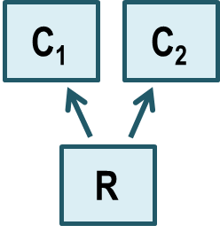
Where: C₁ is the stock for consumer 1
C₂ is the stock for consumer 2
R is the stock for the shared single resource

- How would we modify the conceptual model from Question 2 if the two consumer species were competing over two shared resources?

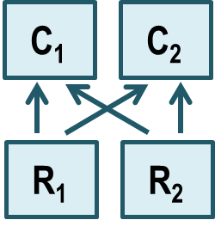
Where: C₁ is the stock for consumer 1
C₂ is the stock for consumer 2
R₁ is the stock for the first shared resource
R₂ is the stock for the second shared resource

- Under the competitive exclusion principle (circle all that apply):

- the consumer with the lowest resource requirement at equilibrium will win
- there can be only one winner of resource competition
- the consumer with the lowest R* will dominate initially
- the consumer with the greatest R* wins

- Which assumptions apply to the following set of equations (circle all that apply)?

${dP_{1}}/{dt}=a_{1}c_{1}RP_{1}- d_{1}P_{1}$ ${dP_{2}}/{dt}=a_{2}c_{2}RP_{2}- d_{2}P_{2}$
$${dR}/{dt}=b_{r}R- d_{r}R-a_{1}RP_{1}- a_{2}{RP}_{2}$$

- in the absence of consumer one, the resources grow exponentially
- consumers encounter prey randomly
- consumers have a satiating (Type II) functional response
- the consumer populations will increase exponentially in the absence of prey
- exploitative competition

- R* for a consumer species is determined by:

- allowing two consumer species to compete over a shared resource and measuring the equilibrium abundance of the resource
- allowing a single consumer species to grow to equilibrium while consuming a single resource and measuring the equilibrium abundance of the consumer
- allowing a single consumer species to grow to equilibrium while consuming two resources and measuring the equilibrium abundance of the resources
- allowing a single consumer species to grow to equilibrium while consuming a single resource and measuring the equilibrium abundance of the resource

- Solve the equation below for R*. What type of functional response does the consumer have in this equation?

$${dP}/{dt}=acRP- d_{p}P$$

Solution: $0=acR^{*}P^{*}- d_{p}P^{*}$ $acR^{*}P^{*}= d_{p}P^{*}$ $\frac{acR^{*}P^{*}}{acP^{*}}= \frac{d_{p}P^{*}}{acP^{*}}$
$$R^{*}= \frac{d_{p}}{ac}$$

Type I functional response

- According to the type II functional response equation below, what happens to the feeding rate, f, when the number of resources is high?

$$f=\frac{f_{max}R}{R+h}$$

- f approaches f_{max}
- f approaches zero
- f approaches 1
- f approaches h

- What is the half-saturation constant, h, for the feeding rate curve below if the maximum feeding rate, f_{max}, is 6?

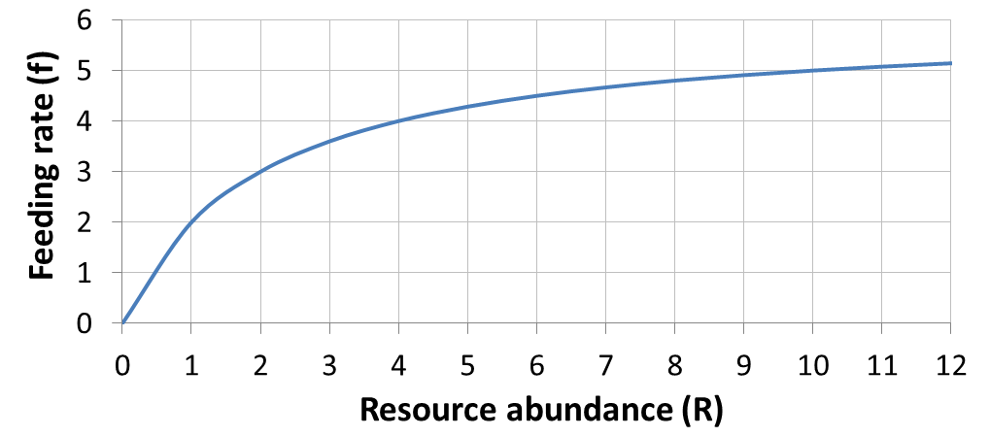

The half-saturation constant, h, is the resource abundance, R, when the feeding rate, f, is half of the maximum value, f_{max}. I.e., h is value of R when f / f_{max} = 0.5.

Since f_{max} = 6, then half of f_{max} equals 3. The value of R when f = 3 is 2 (see circle on figure).

Therefore, h = 2 resources

- Solve the equation below for R*. What type of functional response does the consumer have in this equation?

$${dP}/{dt}=\frac{cf_{max}RP}{R+h}- d_{p}P$$

Solution: You will do this derivation for the Lab 10 report, so I cannot give the derivation here. However, I can provide the final answer that you saw in lecture.

$$R^{*}=\frac{d_{p}h}{cf_{max}-d_{p}}$$

Type II functional response

- According to your R* solution for Question 10, which of the below make a better competitor (circle all that apply)?

- competitor with a low feeding rate
- competitor with a high death rate
- competitor with a low half-saturation constant
- competitor with a high conversion efficiency

- What part of the equation in Question 10 represents the consumer birth rate?

The consumer birth rate is equivalent to the expression:

$$\frac{{cf}_{max}R}{R+h}$$

We can tell the expression above constitutes the consumer birth rate by comparing the equation in Question 10 to a simple equation for consumer exponential growth:

$${dP}/{dt}=b_{p}P- d_{p}P$$

Comparing this equation for consumer exponential growth and the equation in Question 10, the birth rate of the consumer, b_{p}, is replaced by the expression $\left(\frac{{cf}_{max}R}{R+h}\right)$ to express predator births based on prey availability using a type II functional response.
- If the solid curve represents the consumer birth rate, and the dashed line represents the consumer death rate, what is R* for the consumer represented in the figure below?
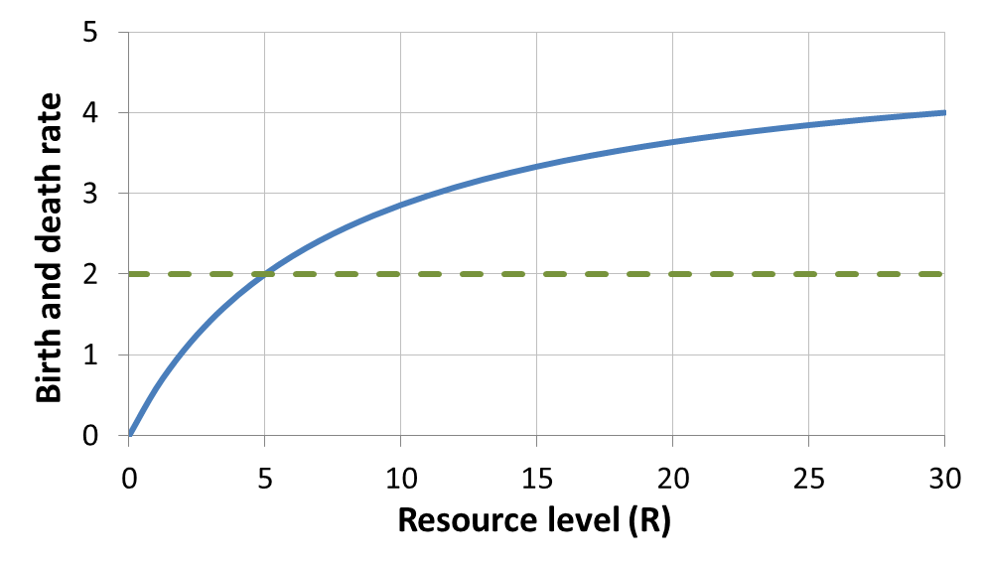
b_{p}
d_{p}
R* occurs at steady state, i.e., when the consumer birth rate equals the consumer death rate. The consumer birth rate and death rate are equal at the point where the lines cross, denoted by the circle above. This point corresponds to a resource level of 5.

Therefore, R* = 5 resources

- Use the following figure to answer the questions below.
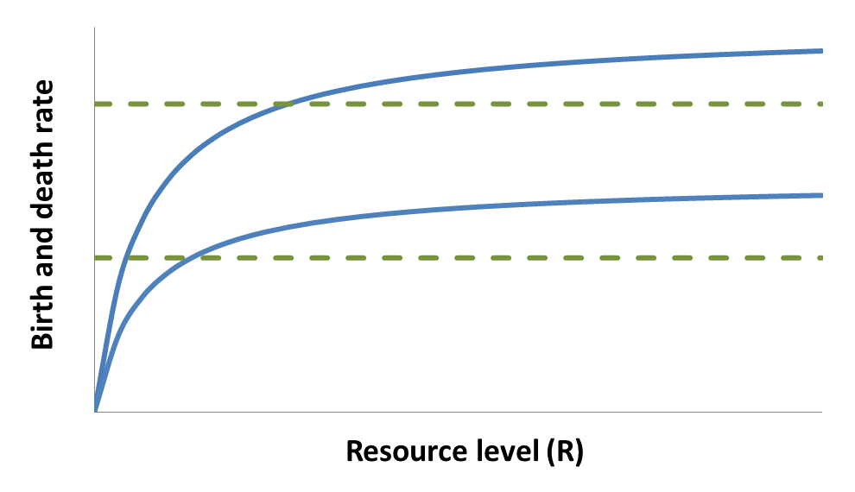
R₁*
R₂*
b₁
d₁
d₂
b₂
Assuming that b₁ and b₂ are functions relating the birth rates of two consumer species (1 and 2) to resource abundance, and that d₁ and d₂ are death rate functions:

- Which species will be the winner of competition if the death rate of both species is given by d₁?

Because the death rate, d₁, is above the birth rate function for consumer 2 at all resource levels, consumer 2 will go extinct. Consumer 1 will be the winner.

- Which species will be the winner of competition if the death rate of both species is given by d₂?

R* for each species occurs where the birth rate curves and death rate line intersect. The death rate, d₂, intersects the birth rate curves for both consumers. The intersection for consumer 1 corresponds to a lower resource abundance (i.e., lower R*) than consumer 2, so consumer 1 will be the winner.
- Circle the correct option from each pair below to describe the characteristics of r- and K-selected species.
r-selected (weedy species)

low birth rate vs. high birth rate

low death rate vs. high death rate

low h vs. high h
K-selected (climax species)

low birth rate vs. high birth rate

low death rate vs. high death rate

low h vs. high h

- Use the following figure to answer the questions below.
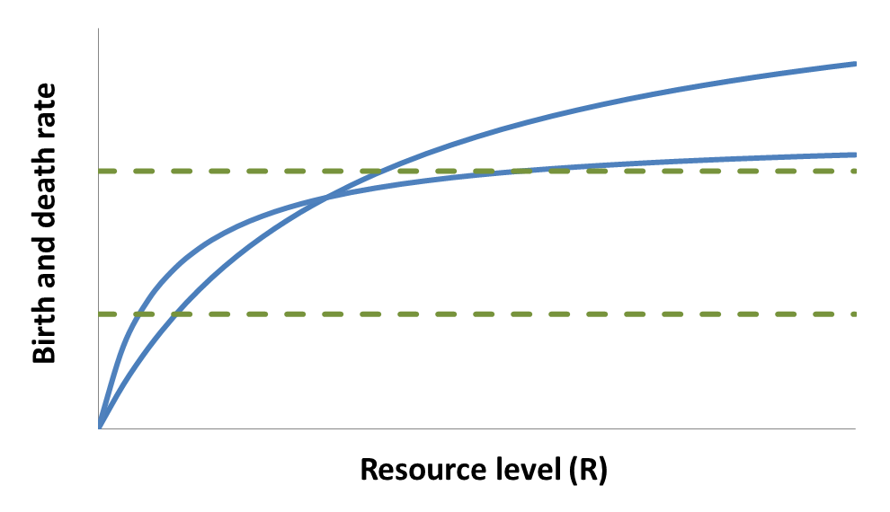
R₁*
R₂*
R₁*
R₂*
b₂
d₁
d₂
b₁
Assuming that b₁ and b₂ are functions relating the birth rates of two consumer species (1 and 2) to resource abundance, and that d₁ and d₂ are death rate functions:

- Which species will be the winner of competition if the death rate of both species is given by d₁?

At the death rate depicted by d₁, consumer 1 will win (R₁* < R₂*).

- Which species will be the winner of competition if the death rate of both species is given by d₂?

At the death rate depicted by d₂, consumer 2 will win (R₂* < R₁*).

- Which species will be the winner of competition if the death rate of consumer 1 is d₁ and the death rate of consumer 2 is d₂?

With the death rate depicted by d₁ for consumer 1 and d₂ for consumer 2,
consumer 2 will win (R₂* < R₁*).

- Given the parameters in part c, would consumer 1 represent a weedy species or a climax species?

Consumer 1 has a higher maximum birth rate (which can be determined by the relative heights of the birth rate curves at high resources) and a higher half-saturation constant (because the birth rate function for consumer 1 is shallower than consumer 2 at low resources), and so consumer 1 would be a weedy species.
- The figure below is a competition-disturbance figure, showing how the abundance of two competing species changes through time with multiple disturbance events (black arrows). Does the consumer with the dashed line represent a weedy species or a climax species?
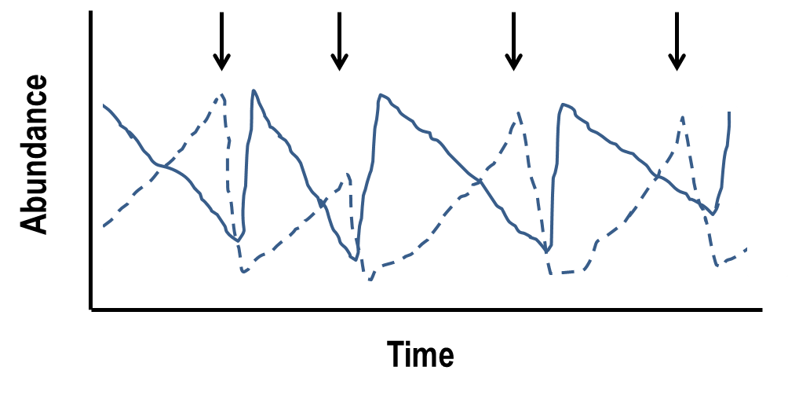
The dashed line must represent a climax species, since the abundance of that consumer grows during times without disturbance, and then declines after a disturbance. The solid line must represent a weedy species, since the abundance of that consumer increases quickly after a disturbance event.

- Which of the following could promote co-existence of competing species, even if one species is a superior competitor for a shared single resource (circle all that apply)?

- harvest of the superior competitor
- periodic disturbances that favor the inferior competitor
- the introduction of a predator species that prefers the inferior competitor
- the inclusion of a second resource for which the inferior competitor (inferior based on the original resource) has a lower R*

- Given one example of an application of competition modeling.

There are many correct answers to this question. Two examples that we discussed in class are:

Reason 1. Competition models are useful for thinking about how natural communities are structured and, therefore, how management actions might affect different types of species (e.g., climax vs. weedy species). For example, a competition model might be useful for determining whether periodic disturbance (such as the use of prescribed fire) would promote co-existence of competing species.

Reason 2. Competition models are useful for evaluating the impact of introduced species that may compete with native species. For example, competition models could be used to evaluate the effect of unintentionally introduced species (e.g., exotic species) and intentionally introduced species (e.g., for biocontrol or restoration) BEFORE the introduction actually occurs.

- **This is a challenging question. Be sure to read the questions for parts a-c carefully.
Note: there may be extraneous information provided.**

A resource has a birth rate of 4 individuals per month and a death rate of 2 individuals per month due to non-predatory sources of mortality. The resource is eaten by two consumers that are not aggressive to each other. The conversion efficiency of both consumers is 0.5. Consumer 1 has an attack rate that is 2 times greater than the attack rate of consumer 2. Consumer 1 has a death rate that is 4 times greater than the death rate of consumer 2. Given the equations below, answer the following three questions.

${dP_{1}}/{dt}=a_{1}c_{1}RP_{1}- d_{1}P_{1}$ ${dP_{2}}/{dt}=a_{2}c_{2}RP_{2}- d_{2}P_{2}$
$${dR}/{dt}=b_{r}R- d_{r}R-a_{1}RP_{1}- a_{2}{RP}_{2}$$

- Which consumer has the greater birth rate?

Consumer 1 has an attack rate that is 2 times greater than the attack rate of consumer 2. We can define the attack rates for consumers 1 and 2, which are a₁ and a₂, respectively, in terms of their relative magnitudes as: a₁ = 2a and a₂ = a

Both consumers have a conversion efficiency of 0.5. So, c₁ = c₂ = 0.5.

The birth rate of the consumers based on the equations above is acR. Using the information above, we can determine the birth rates for both consumers (b₁ and b₂) as:

$b_{1}=a_{1}c_{1}R=2a\left(0.5\right)R=aR$

$b_{2}=a_{2}c_{2}R=a\left(0.5\right)R=0.5aR$

Based on these equations, the birth rate for consumer 1 is aR, whereas the birth rate for consumer 2 is 0.5aR, indicating the birth rate for consumer 2 is half the birth rate of consumer 1. Therefore, consumer 1 has the greater birth rate.

- What is the growth rate of each consumer at equilibrium?

The growth rate of each consumer at equilibrium is zero!

Answer to part c on next page…

- Does one species drive the other extinct at steady state? If so, which persists and which goes extinct?

Consumer 1 has a death rate that is 4 times greater than the death rate of consumer 2. We can define the death rates for consumers 1 and 2, which are d₁ and d₂, respectively, in terms of their relative magnitudes as: d₁ = 4d and d₂ = d.

From part a, a₁ = 2a and a₂ = a, and c₁ = c₂ = 0.5.

To determine if one consumer out-competes the other, we need to know R* for each consumer at equilibrium. The equations for R* for each consumer are (see Question 7 for the derivation of the R* equations):

${R_{1}}^{*}= \frac{d_{1}}{a_{1}c_{1}}$ ${R_{2}}^{*}= \frac{d_{2}}{a_{2}c_{2}}$

Plugging in the relationships above for the consumer death rates, attack rates, and conversion efficiencies yields:
${R_{1}}^{*}= \frac{4d}{2a(0.5)}$ ${R_{2}}^{*}= \frac{d}{a(0.5)}$

Which simplify to:
${R_{1}}^{*}= 4\frac{d}{a}$ ${R_{2}}^{*}= 2\frac{d}{a}$

Based on these equations, R₁* is twice as large as R₂*, so R* for consumer 2 is lower than R* for consumer 1. Therefore, consumer 2 is the superior competitor and will, therefore, be alive at steady state. Consumer 1 will be extinct.

