FW364 Name: _______________________

Final Exam

May 1, 2012 Section: ______________________

**Be sure to read all questions carefully. Always give the best answer.**

**Show your work so I can give partial credit.**

1. (3 pts.) Which of the following linkages is characteristic of a predator-prey interaction?
   1. prey births to predator deaths
   2. prey deaths to predator deaths
   3. predator deaths to prey births
   4. prey deaths to predator births
2. (3 pts.) Which type of predator (consumer) is the most effective at controlling the abundance of its prey (resource)?
   1. a carnivore
   2. a scramble predator
   3. an herbivore
   4. a territorial predator
3. (3 pts.) Predator attack rate (*a*) is:
   1. the number of prey killed by the predator population per unit time
   2. the number of prey killed by a single predator per unit time
   3. the proportion of the prey population killed by the predator population per unit time
   4. the proportion of the prey population killed by a single predator per unit time
4. (3 pts.) Which of the following statements is true?
   1. the competitor with the greatest resource requirement at equilibrium will win
   2. steady-state biomass of prey must be greater than steady-state biomass of predators
   3. the net production of the prey must be larger than the net production of the predator at steady state
   4. the competitor with the lower R* will dominate at all times
5. (3 pts.) In a closed system with one prey species and one predator species, if prey abundance (**V**) is above **V\***, then:
   1. the predator abundance will increase
   2. the prey’s birth rate will exceed its death rate
   3. the system is at steady state
   4. none of the above
6. (3 pts.) Predator feeding rate is:
   1. the number of prey killed by the predator population per unit time
   2. the number of prey killed by a single predator per unit time
   3. the proportion of the prey population killed by the predator population per unit time
   4. the proportion of the prey population killed by a single predator per unit time
7. (3 pts.) Territoriality by predators can be represented in models by including (as we did in our Stella modeling):
   1. an equation with a half saturation constant
   2. steady state dynamics
   3. zero predator birth rate above a certain predator density
   4. satiation using a Type II functional response
8. (3 pts.) The equations below represent what type of competition, assuming the two consumers are different species?

${dP_{1}}/{dt}=a_{1}c_{1}RP_{1}- d_{1}P_{1}$ ${dP_{2}}/{dt}=a_{2}c_{2}RP_{2}- d_{2}P_{2}$

$${dR}/{dt}=b_{r}R- d_{r}R-a_{1}RP_{1}- a_{2}{RP}_{2}$$

1. interspecific exploitative competition
2. interspecific interference competition
3. intraspecific exploitative competition
4. intraspecific interference competition
5. (3 pts.) What is the (approximate) instantaneous growth rate (obtained by using the tangent method) at point A on the figure below?

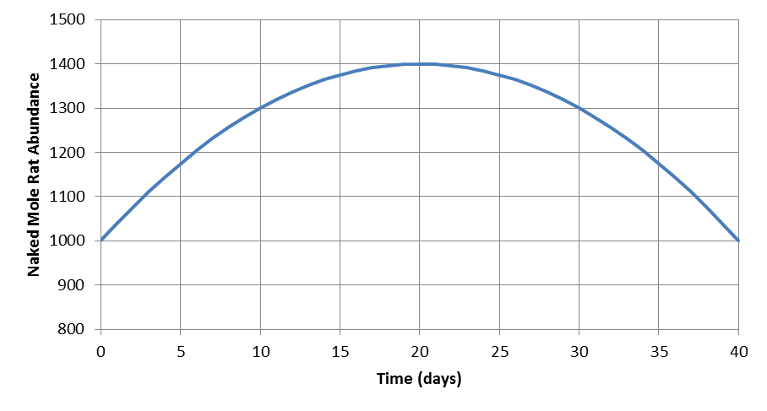

**A**

* 1. 10 naked mole rats per day
  2. 20 naked mole rats per day
  3. -20 naked mole rats per day
  4. -10 naked mole rats per day

Refer to the following pair of equations, which describe the dynamics of a predator-prey interaction, in answering questions 10 through 13:

$${dV}/{dt}=b_{max}\left(1-\frac{V}{K}\right)V-aVP$$

$${dP}/{dt}=acVP-d_{p}P$$

1. (3 pts.) What is *bmax*?
   1. the birth rate of the predator when the predator is not satiated
   2. the birth rate of the predator when the predator is satiated
   3. the birth rate of the prey at low competition
   4. the birth rate of the prey at high competition
2. (3 pts.) What will be the dynamics of the prey in the absence of predatorsif *V* < *K*?
   1. increase to steady state
   2. exponential increase
   3. exponential decrease
   4. decrease to steady state
3. (3 pts.) What will be the dynamics of the predator (*P*) in the absence of prey?
   1. increase to steady state
   2. exponential increase
   3. exponential decrease
   4. decrease to steady state
4. (3 pts.) Which of the following is an assumption of these equations?
5. in the absence of predation, prey grow exponentially
6. predators have a type II functional response
7. predators encounter prey randomly (i.e., well-mixed environment)
8. the predator exhibits contest density dependence
9. (3 pts.) A weedy species (high birth rate at high resource levels, but high R*) can persist in an environment despite the presence of a superior competitor if:
   1. disturbance rates are high
   2. predators are rare
   3. the environment is constant
   4. there is only one resource
10. (4 pts.) There are 1000 prey and 10 predators in a pond. Each predator eats 2 prey in a day. What is the attack rate (assuming the predators have a Type I functional response)?
11. (5 pts.) Draw a figure on which you identify the meaning of the parameter “***fmax***” in the following predator-prey equations. Be sure to label **both** axes.
$${dV}/{dt}=b_{v}V-d_{v}V-\frac{f_{max}VP}{V+h}$$

$${dP}/{dt}=\frac{cf_{max}VP}{V+h}-d_{p}P$$

12. (3 pts.) Briefly describe what *h* is in the equations in question 16.
13. (4 pts.) Briefly explain why a “natural regulation strategy” is not a reasonable option for deer management in the state of Michigan from the perspective of predator-prey interactions.
14. (3 pts.) **Circle** the correct choice in the parentheses: Given a pair of competing species with identical feeding rates and conversion efficiencies, the one with the ( **higher lower** ) death rate will dominate.
15. (3 pts.) Which of the lines on the figure below (line 1 or 2) likely depicts the response of plant abundance to an increase in soil fertility (starting at time 5) in an ecosystem where herbivores are **not** territorial?



**Plant Abundance**

1. (6 pts.) We stock two species of fish (the blue sunfish and the red sunfish), both of which eat only *Daphnia*, into two previously fishless ponds and allow each population to grow by itself for several years. After the fish populations reach a stable abundance, we then sample the ponds and determine the average abundance of *Daphnia* in each pond. We find that *Daphnia* abundance is 5 per liter in the pond with blue sunfish and 2 per liter in the pond with red sunfish. We now stock the two species into a single pond and watch them compete for *Daphnia*. Based on your deep understanding of resource competition, which species do you predict will ultimately win the competition? What is the basis of your choice?
2. (5 pts.) The following equations describe the dynamics of a predator and prey:

$${dV}/{dt}=b_{max}\left(1-\frac{V}{K}\right)V-aVP$$

$${dP}/{dt}=acVP-d_{p}P$$

Given the following parameters, what is the **equilibrium density** of the **prey**? Show your work!

*bmax* = 0.5 year-1

*K* = 2000 prey

*a* = 0.01 predator-1 year-1

*c* = 0.2

*dp* = 0.2 year-1

1. (6 pts.) Draw two curves on a **single** graph that depict how the per capita birth rate functions for two competing species change with resource abundance, where species 1 is the early successional (weedy) species and species 2 is the late-successional (climax) species. Be sure to **label** each birth rate curve with “species 1” or “species 2”, and **label** both axes of your graph.

1. (3 pts.) Based on your curves from the previous question, which species would likely be favored by a high death rate?
2. (10 pts.) Given this equation for the minimum resource requirement: , where *dp* is the consumer death rate, *h* is the half saturation constant of the relationship between consumer birth rate and resource abundance, and *bmax* is the maximum birth rate, match the four cases with the graph that most likely describes the dynamics of the two competing consumer species.

|  |  |  |  |  |  |  |  |  |
| --- | --- | --- | --- | --- | --- | --- | --- | --- |
|  | **Case 1** | | **Case 2** | | **Case 3** | | **Case 4** | |
| **Parameter** | **Species 1** | **Species 2** | **Species 1** | **Species 2** | **Species 1** | **Species 2** | **Species 1** | **Species 2** |
| *bmax* | 2.0 | 1.0 | 1.6 | 2.0 | 2.0 | 1.6 | 1.0 | 2.2 |
| *h* | 1.0 | 1.0 | 1.0 | 1.0 | 1.0 | 1.0 | 1.0 | 1.0 |
| *dp* | 0.5 | 0.2 | 0.3 | 0.2 | 0.2 | 0.2 | 0.2 | 0.5 |

1. (6 pts.) Given the following birth rate and death rate functions for a pair of competing consumers:

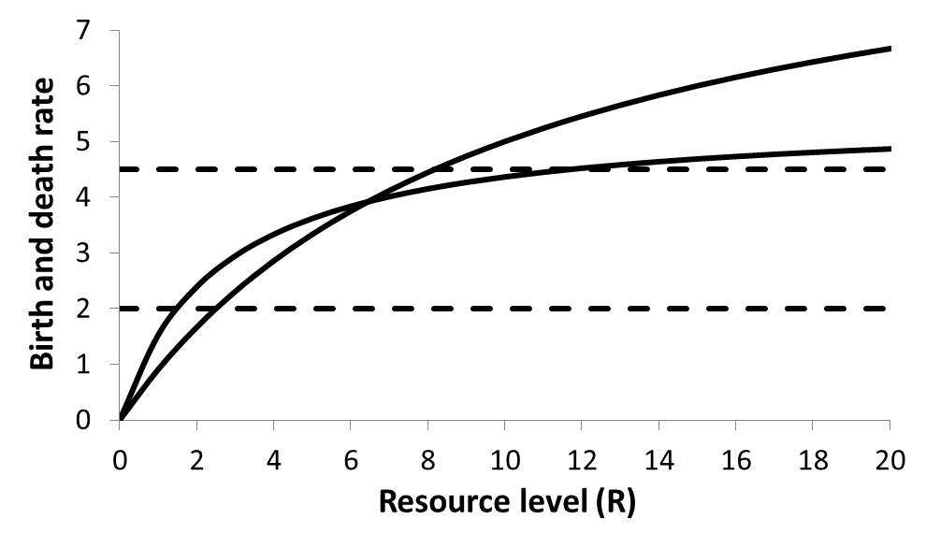

*b*2

*d*2

*d*1

*b*1

* 1. If *b1* describes the birth rate of consumer 1, *b2*describes the birth rate of consumer 2, and *d1* is the death rate of both consumers, which consumer would you predict to be the winner at steady state?
  2. If *b1* describes the birth rate of consumer 1, *b2* describes the birth rate of consumer 2, and *d2* is the death rate of both consumers, which consumer would you predict to be the winner at steady state?
  3. If *b1* describes the birth rate of consumer 1, *b2* describes the birth rate of consumer 2, *d1* is the death rate of consumer 1, and *d2* is the death rate of consumer 2, which consumer would you predict to be the winner at steady state?

**Bonus Questions**:

BQ1. (2 pts.) Circle the part of the equation below that represents the birth rate of the consumer.

$${dP}/{dt}=\frac{c{ f}_{max } R P}{R+h}- d_{p} P$$

BQ 2. (2 pts.) Give one management application of **any** of the models we have discussed this semester. Be sure to state the type of model and the management application.