FW364 Name: _______________________

Final Exam KEY

May 1, 2012 Section: ______________________

**Be sure to read all questions carefully. Always give the best answer.**

**Show your work so I can give partial credit.**

1. (3 pts.) Which of the following linkages is characteristic of a predator-prey interaction?
   1. prey births to predator deaths
   2. prey deaths to predator deaths
   3. predator deaths to prey births
   4. **prey deaths to predator births**
2. (3 pts.) Which type of predator (consumer) is the most effective at controlling the abundance of its prey (resource)?
   1. a carnivore
   2. **a scramble predator**
   3. an herbivore
   4. a territorial predator
3. (3 pts.) Predator attack rate (*a*) is:
   1. the number of prey killed by the predator population per unit time
   2. the number of prey killed by a single predator per unit time
   3. the proportion of the prey population killed by the predator population per unit time
   4. **the proportion of the prey population killed by a single predator per unit time**
4. (3 pts.) Which of the following statements is true?
   1. the competitor with the greatest resource requirement at equilibrium will win
   2. steady-state biomass of prey must be greater than steady-state biomass of predators
   3. **the net production of the prey must be larger than the net production of the predator at steady state**
   4. the competitor with the lower R* will dominate at all times
5. (3 pts.) In a closed system with one prey species and one predator species, if prey abundance (**V**) is above **V\***, then:
   1. **the predator abundance will increase**
   2. the prey’s birth rate will exceed its death rate
   3. the system is at steady state
   4. none of the above
6. (3 pts.) Predator feeding rate is:
   1. the number of prey killed by the predator population per unit time
   2. **the number of prey killed by a single predator per unit time**
   3. the proportion of the prey population killed by the predator population per unit time
   4. the proportion of the prey population killed by a single predator per unit time
7. (3 pts.) Territoriality by predators can be represented in models by including (as we did in our Stella modeling):
   1. an equation with a half saturation constant
   2. steady state dynamics
   3. **zero predator birth rate above a certain predator density**
   4. satiation using a Type II functional response
8. (3 pts.) The equations below represent what type of competition, assuming the two consumers are different species?

${dP_{1}}/{dt}=a_{1}c_{1}RP_{1}- d_{1}P_{1}$ ${dP_{2}}/{dt}=a_{2}c_{2}RP_{2}- d_{2}P_{2}$

$${dR}/{dt}=b_{r}R- d_{r}R-a_{1}RP_{1}- a_{2}{RP}_{2}$$

1. **interspecific exploitative competition**
2. interspecific interference competition
3. intraspecific exploitative competition
4. intraspecific interference competition
5. (3 pts.) What is the (approximate) instantaneous growth rate (obtained by using the tangent method) at point A on the figure below?

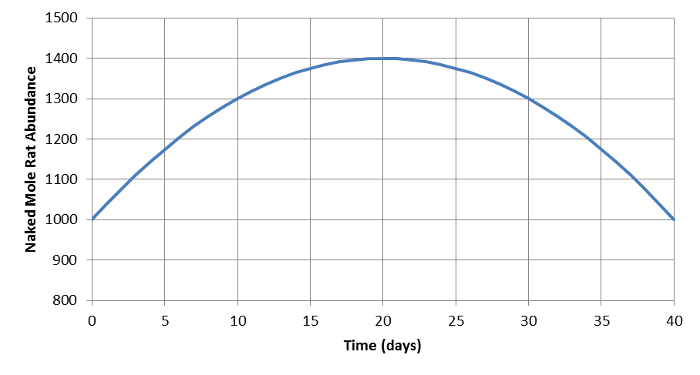

**A**

* 1. 10 naked mole rats per day
  2. 20 naked mole rats per day
  3. **-20 naked mole rats per day**
  4. -10 naked mole rats per day

Refer to the following pair of equations, which describe the dynamics of a predator-prey interaction, in answering questions 10 through 13:

$${dV}/{dt}=b_{max}\left(1-\frac{V}{K}\right)V-aVP$$

$${dP}/{dt}=acVP-d_{p}P$$

1. (3 pts.) What is *bmax*?
   1. the birth rate of the predator when the predator is not satiated
   2. the birth rate of the predator when the predator is satiated
   3. **the birth rate of the prey at low competition**
   4. the birth rate of the prey at high competition
2. (3 pts.) What will be the dynamics of the prey in the absence of predatorsif *V* < *K*?
   1. **increase to steady state**
   2. exponential increase
   3. exponential decrease
   4. decrease to steady state
3. (3 pts.) What will be the dynamics of the predator (*P*) in the absence of prey?
   1. increase to steady state
   2. exponential increase
   3. **exponential decrease**
   4. decrease to steady state
4. (3 pts.) Which of the following is an assumption of these equations?
5. in the absence of predation, prey grow exponentially
6. predators have a type II functional response
7. **predators encounter prey randomly (i.e., well-mixed environment)**
8. the predator exhibits contest density dependence
9. (3 pts.) A weedy species (high birth rate at high resource levels, but high R*) can persist in an environment despite the presence of a superior competitor if:
   1. **disturbance rates are high**
   2. predators are rare
   3. the environment is constant
   4. there is only one resource
10. (4 pts.) There are 1000 prey and 10 predators in a pond. Each predator eats 2 prey in a day. What is the attack rate (assuming the predators have a Type I functional response)?

**Givens:**

***V* = 1000 prey**

***P* = 10 predators (unnecessary information)**

***aV* = 2 prey per predator per day = predator feeding rate = *f***

**Predator attack rate = *a***

***f* = *aV* 🡪 *a* = *f / V***

**a = 2 prey/(pred*day) / 1000 prey**

***a* = 0.002 predator-1 day-1**

1. (5 pts.) Draw a figure on which you identify the meaning of the parameter “***fmax***” in the following predator-prey equations. Be sure to label **both** axes.

$${dV}/{dt}=b_{v}V-d_{v}V-\frac{f_{max}VP}{V+h}$$

$${dP}/{dt}=\frac{cf_{max}VP}{V+h}-d_{p}P$$

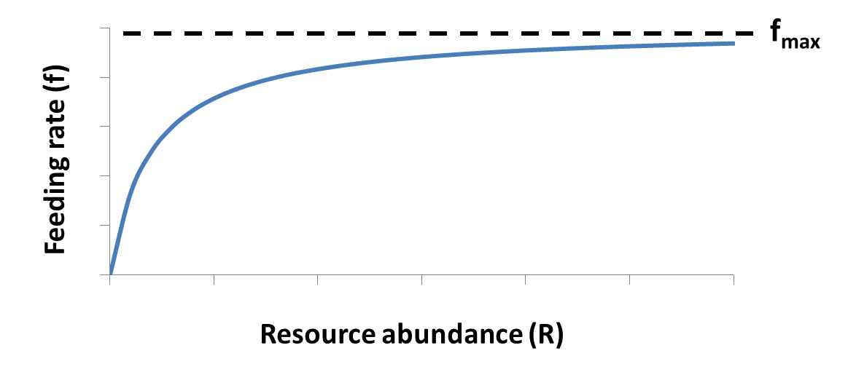

1. (3 pts.) Briefly describe what *h* is in the equations in question 16.

***h* is the consumer half saturation coefficient. Specifically, *h* is the value of *R* (i.e., resource abundance) when the feeding rate is half of the maximum value.**

1. (4 pts.) Briefly explain why a natural regulation strategy is not a reasonable option for deer management in the state of Michigan from the perspective of predator-prey interactions.

**There are few natural predators of deer in Michigan, so natural regulation may result in serious overpopulation of deer and degradation of the deer’s resource base. Spread of tuberculosis in a high density deer herd is another example of a potential problem.**

1. (3 pts.) **Circle** the correct choice in the parentheses: Given a pair of competing species with identical feeding rates and conversion efficiencies, the one with the ( **higher lower** ) death rate will dominate.
2. (3 pts.) Which of the lines on the figure below (line 1 or 2) likely depicts the response of plant abundance to an increase in soil fertility (starting at time 5) in an ecosystem where herbivores are **not** territorial?



**Plant Abundance**

**Line 1**

1. (6 pts.) We stock two species of fish (the blue sunfish and the red sunfish), both of which eat only *Daphnia*, into two previously fishless ponds and allow each population to grow by itself for several years. After the fish populations reach a stable abundance, we then sample the ponds and determine the average abundance of *Daphnia* in each pond. We find that *Daphnia* abundance is 5 per liter in the pond with blue sunfish and 2 per liter in the pond with red sunfish. We now stock the two species into a single pond and watch them compete for *Daphnia*. Based on your deep understanding of resource competition, which species do you predict will ultimately win the competition? What is the basis of your choice?

**I predict that the red sunfish will win the competition because it has a lower R*, which is the amount of resource remaining at steady state (2 *Daphnia* per L for the red sunfish versus 5 *Daphnia* per L for the blue sunfish).**

1. (5 pts.) The following equations describe the dynamics of a predator and prey:

$${dV}/{dt}=b_{max}\left(1-\frac{V}{K}\right)V-aVP$$

$${dP}/{dt}=acVP-d_{p}P$$

Given the following parameters, what is the **equilibrium density** of the **prey**? Show your work!

*bmax* = 0.5 year-1

*K* = 2000 prey

*a* = 0.01 predator-1 year-1

*c* = 0.2

*dp* = 0.2 year-1

**Solve *dP* / *dt* for *V*\*, which yields:**

$$V^{*}=\frac{d_{p}}{ac}$$

**Substituting the given information above:**

$V^{*}=\frac{0.2 {year}^{-1}}{0.01 {predator}^{-1} {year}^{-1}*0.2}$**= 100 prey**

1. (6 pts.) Draw two curves on a **single** graph that depict how the per capita birth rate functions for two competing species change with resource abundance, where species 1 is the early successional (weedy) species and species 2 is the late-successional (climax) species. Be sure to **label** each birth rate curve with “species 1” or “species 2”, and **label** both axes of your graph.

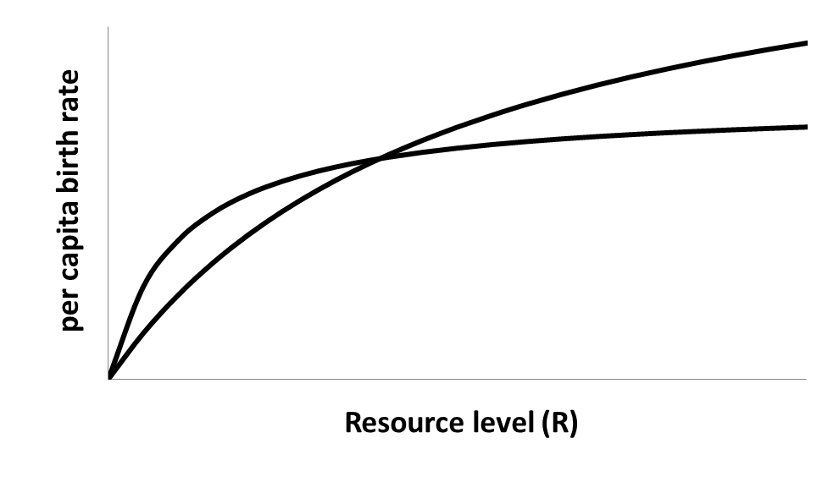

**Species 1**

**Species 2**

1. (3 pts.) Based on your curves from the previous question, which species would likely be favored by a high death rate?

**Species 1 should be favored because it has a higher maximum birth rate and so can withstand a higher death rate without going extinct.**

1. (10 pts.) Given this equation for the minimum resource requirement: , where *dp* is the consumer death rate, *h* is the half saturation constant of the relationship between consumer birth rate and resource abundance, and *bmax* is the maximum birth rate, match the four cases with the graph that most likely describes the dynamics of the two competing consumer species.

|  |  |  |  |  |  |  |  |  |
| --- | --- | --- | --- | --- | --- | --- | --- | --- |
|  | **Case 1** | | **Case 2** | | **Case 3** | | **Case 4** | |
| **Parameter** | **Species 1** | **Species 2** | **Species 1** | **Species 2** | **Species 1** | **Species 2** | **Species 1** | **Species 2** |
| *bmax* | 2.0 | 1.0 | 1.6 | 2.0 | 2.0 | 1.6 | 1.0 | 2.2 |
| *h* | 1.0 | 1.0 | 1.0 | 1.0 | 1.0 | 1.0 | 1.0 | 1.0 |
| *dp* | 0.5 | 0.2 | 0.3 | 0.2 | 0.2 | 0.2 | 0.2 | 0.5 |
| ***R\**** | **0.33** | **0.25** | **0.23** | **0.11** | **0.11** | **0.14** | **0.25** | **0.29** |

**Case 1 = A**

**Case 2 = B**

**Case 3 = C**

**Case 4 = D**

1. (6 pts.) Given the following birth rate and death rate functions for a pair of competing consumers:

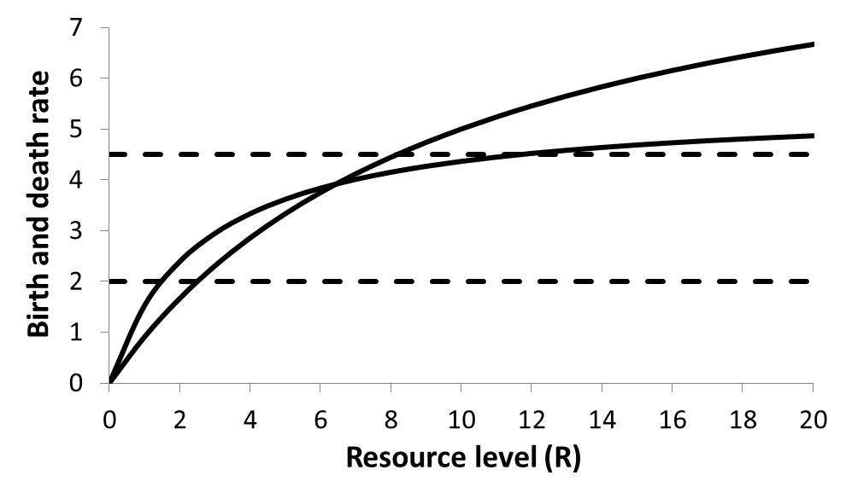

*b*2

*d*2

*d*1

*b*1

*R*2*

*R*1*

*R*1*

*R*2*

* 1. If *b1* describes the birth rate of consumer 1, *b2*describes the birth rate of consumer 2, and *d1* is the death rate of both consumers, which consumer would you predict to be the winner at steady state?

**Consumer 1**

* 1. If *b1* describes the birth rate of consumer 1, *b2* describes the birth rate of consumer 2, and *d2* is the death rate of both consumers, which consumer would you predict to be the winner at steady state?

**Consumer 2**

* 1. If *b1* describes the birth rate of consumer 1, *b2* describes the birth rate of consumer 2, *d1* is the death rate of consumer 1, and *d2* is the death rate of consumer 2, which consumer would you predict to be the winner at steady state?

**Consumer 2**

**Bonus Questions**:

BQ1. (2 pts.) Circle the part of the equation below that represents the birth rate of the consumer.

$${dP}/{dt}=\frac{c{ f}_{max } R P}{R+h}- d_{p} P$$

$$\frac{{cf}_{max}R}{R+h}$$

BQ 2. (2 pts.) Give one management application of **any** of the models we have discussed this semester. Be sure to state the type of model and the management application.

**Lots of answers here, such as:**

**Allee effects models for threatened or endangered species conservation**

**Competition models for species invasions**

**Population growth models for species re-introduction**

**Age-structured models for fisheries management**