Name: KEY!
FW364 Midterm 1:
Mass balance Questions
- (9 points) My Grandma Parr died in 1997 and is buried in Kalkaska, Michigan. Due to improved carbon tracking technology and stable isotopes, MSU scientists were able to track carbon from my Grandma into a wolf in the Kalkaska County. Please draw a stock and flow model (without any numbers, but please label the stocks and flows) to show how carbon from my Grandma might have been able to get into the wolf. Note: The wolf did not dig up the body and eat it.
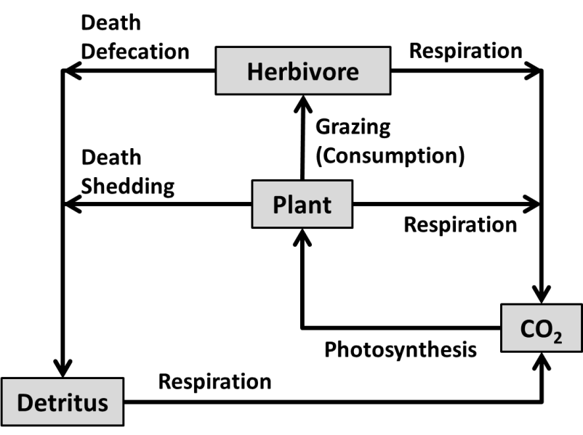The figure would be similar to this one, with a wolf eating the herbivore, and Grandma Parr being part of the detritus pool. They don’t need to include the death/shedding/pooping categories, or the respiration from plants/herbivores/wolves. each pool/stock and flow would be worth ~1 point, so 9 points available total. Subtract one point if they have any extra incorrect flows/stocks.
- Suppose that a chemical spill occurs in the Kalamazoo River and the contaminated water enters Lake Michigan.
  - (2 points) We need to put out a public health advisory about how long the lake will be contaminated (assuming the chemical stays dissolved and does not enter the food chain or get deposited in the sediments). What concept discussed in class would you need to use to figure out how long the lake will be contaminated?

Residence Time Problems(or Stock/Flow Models or Mass Balance Problems)

  - (3 points) What information would you need in order to calculate the length of time the lake would be contaminated? Please list all components of the calculation along with appropriate units. Assume the lake is at steady state.

Turnover Time (years)=Stocks (m³)/F (m³/year) (or similar—could use days instead of years or another volume unit instead of m³). (one point for stocks (volume), one point for flows, and one point for the units).

We would need the total volume of Lake Michigan and flow rate of water either entering the lake or leaving the lake.

  - (2 points) Imagine this contamination happened in Lake Lansing instead of Lake Michigan. Would you predict that the amount of time Lake Michigan would be contaminated would be longer or shorter than how long Lake Lansing would be contaminated? Why?

Lake Lansing’s residence time should be shorter because the stock is much much smaller.

- (3 points) We are studying a prairie ecosystem in Barry County, Michigan and we need to measure some baseline data. How might we be able to measure Annual Net Primary Productivity (NPP)?
They should say something about measuring plant mass by measuring the accumulated mass gained in the past year (may describe for annuals as chopping down the biomass or for trees by dbh tapes).

Quantitative tools (general lecture),
- We are trying to build a simple model for a population of porcupines in the Upper Penninsula. We know that porcupines only have one litter of porcupettes per year. We don’t have much information on this population, as they are very secretive. Which of the following categories of models would make the most sense for us to use? Circle one for each category below:
- (2 points) Discrete or continuous? Why?
They only have babies once a year/set breeding season (or similar). One point for discrete, one point for explanation.
- (2 points) Deterministic or stochastic? Why?
We don’t have much information on the variability for this population, or they could choose stochastic if they want to give a range of estimates since we don’t have high certainty (either answer is acceptable if the defense makes sense). Generally trying to get them to say that deterministic models don’t include variability (only produce one answer) and stochastic models do include variability (producing a range of answers). One point for their answer, one point for explanation.
Population growth
- Apparently the folks in Bucharest, Romania have a large problem with wild dogs that is causing a large debate around the world about what to do with feral animals. According to the BBC, officials said about 1,100 people were bitten by stray dogs in the first four months of 2013. After the mauling of a 4 year old boy, officials are suggesting that all the wild dogs that cannot be adopted be euthanized. Animal rights activists suggest that spay/neuter programs should be implemented to control the population. You have been asked to provide some population estimates for this population of wild dogs under different management regimes. There are currently 65,000 (!) wild dogs in the city.
  - (2 points) What other information/variables (if any) beyond what is provided on the next page do you need information for or must assume are negligible in order to determine changes in population sizes for these dogs?

You have to assume no immigration! Also, we are assuming no euthanasia in this problem. We are considering each individual to be equal. (only one of these answers or similar are all that is needed here).

  - (10 points) Using the information provided below, please calculate the population one year from now under different sterilization regimes (and no euthanasia/harvesting). Showing the setup for each problem in terms of calculations is part of the answer and is required.

Current population of feral dogs: 65,000
Wild Dog birthrate (no sterilization): 4.90
Wild Dog birthrate (moderate sterilation): 2.45
Wild Dog birthrate (complete sterilization): 0
Wild Dog deathrate: 0.33
Wild Dog Adoption (emigration) rate: 0.20

Sterilzation Treatment | Population in one year with no euthanasia
No Sterilization
Moderate Sterilization
Complete Sterilization

N_{t+1} = N_{t}λ, where N_{t} = 65,000 (2 points for correct set up)
λ = 1 + birth rate - death rate – adoption rate (2 points for correct growth rate set up)
No Sterilization: λ = 1 + 4.90 – 0.33 - 0.20 = 5.37 (so the population will still grow)
N_{t} = 65,000(5.37) = 349,050 dogs (2 points)
Moderate Sterilization: λ = 1 + 2.45 – 0.33 - 0.20 = 2.92 (so the population will still grow)
N_{t} = 65,000(2.92) = 189,080 dogs (2 points)
Complete Sterilization: λ = 1 + 0 – 0.33 - 0.20 = 0.47 (so the population will shrink)
N_{t} = 65,000(0.47) = 30,550 dogs (2 points)
Partial credit is awarded for correct setup.

  - (8 points) Officials would like to reduce the population size of wild dogs to one dog (or functionally extinct). Even if they sterilized all the dogs and the birth rate was 0, how long would it take for the population to go extinct (consider N_{t}=1)?
N_{t} = N₀λ^{t}, where N₀ = 65,000 (2 points for correct set up)
λ = 1 + birth rate - death rate – adoption rate (2 points for correct growth rate set up)

1=65000(1+0-0.33-0.2)^{t}
1/65000=(0.47)^{t}
0.0000153846=0.47^{t}
Log (0.0000153846)=log(0.47)^{t} (you could also use the natural log).
Log (0.0000153846)=t*log(0.47)
-4.8129=t*(-0.3279)
-4.8129/(-0.3279)=t
t=14.68 years (2 points for showing correct set up, 2 points for final answer)

