FW364 Name: _______________________
Midterm II Exam
March 28, 2012 Section: ______________________

Be sure to read all questions carefully. Always give the best answer.
Show your work so I can give partial credit.

- (3 pts.) A negative effect on per capita birth rate of an increase in population density is an example of:

a. positive feedback
b. negative feedback
c. stochastic variation
d. extinction via demographic stochasticity

- (3 pts.) Below is the equation describing how the population growth rate (λ) changes with density (N_{t}) for scramble competition. What happens to λ when N_{t} is very small?

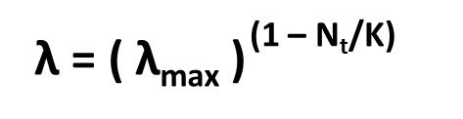
a. λ approaches 0
b. λ approaches λ_{max}
c. λ approaches 1
d. λ is less than 0

- (3 pts.) The following data were obtained from a breeding colony of penguins over a period of years, as the population recovered from near extinction.

size of colony  (# of breeding pairs) | # of chicks produced
15 | 10
20 | 15
30 | 25
50 | 50
100 | 120

This population shows evidence of:

a. density dependence
b. exponential growth
c. stochastic breeding success
d. an Allee effect

4. (3 pts.) The fundamental idea of a metapopulation is:

a. local extinction, global persistence
b. local extinction, global extinction
c. local persistence, global persistence
d. local persistence, global extinction

5. (3 pts.) In order for a metapopulation to persist:

a. at least one of the local populations must be a sink population
b. at least one of the local populations must be a source population
c. all of the local populations must have a λ greater than 1
d. immigration must be greater than emigration

6. (3 pts.) Distance among local populations has what affect(s) on metapopulation persistence?

a. increased distance increases metapopulation persistence due to decreased spatial correlation
b. decreased distance increases metapopulation persistence due to increased dispersal
c. distance has no effect on metapopulation persistence
d. a) and b) above both apply

- (3 pts.) In Ramas, the standard deviation matrix in a stage-structured model represents:

a. deterministic variation in survival and fecundity rates
b. environmental stochasticity in survival and fecundity rates
c. survival and fecundity rates at the stable age distribution
d. all of the above

- (4 pts.) The highlighted elements in the following Leslie matrix for an age-structured population represent:

_{X} | _{X} | _{X} | _{X}
_{X} | _{X} | _{X} | _{X}
_{X} | _{X} | _{X} | _{X}
_{X} | _{X} | _{X} | _{X}

a. impossible transitions (so equal 0)
b. fecundity rates of each age class
c. survival rates of each age class
d. none of the above
- (4 pts.) Draw a graph that illustrates the relationship between per capita death rate (y-axis) and population size (x-axis) for a population in which density dependence is operating.

- (4 pts.) Draw a graph that illustrates the relationship between per capita birth rate (y-axis) and population size (x-axis) for a population in which density dependence is operating.

- (6 pts.) Draw a graph that illustrates the relationships between per capita population growth rate (y-axis) and population size (x-axis) for scramble and contest density dependence. Draw these relationships on the same figure. Be sure to clearly label which relationship is for scramble and which relationship is for contest density dependence.

- (7 pts.) The three figures below are replacement curves. Using the choices next to each curve, circle whether the curves illustrate either scramble or contest competition, and whether Allee effects are present. Mark all equilibria on the curves (by drawing a dot) and label whether those equilibria are stable or unstable. Hint: To determine whether equilibria are stable, pick a few starting population sizes and see how the population progresses.

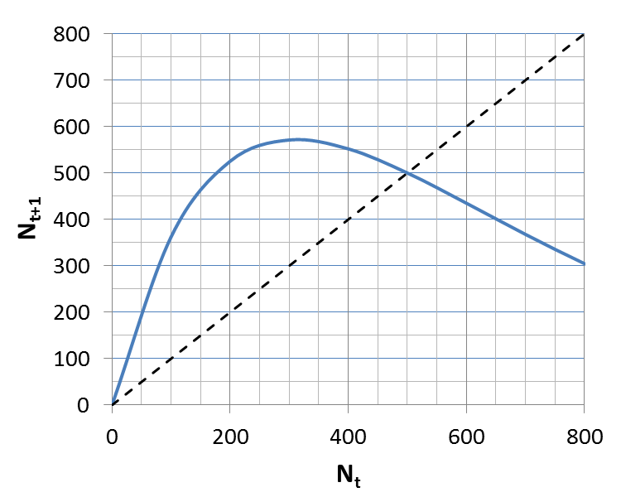
Scramble OR Contest

Allee effects present OR No Allee effects
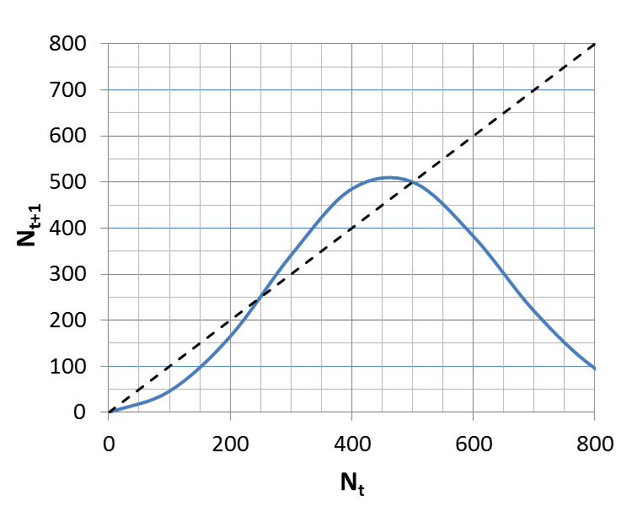
Scramble OR Contest

Allee effects present OR No Allee effects
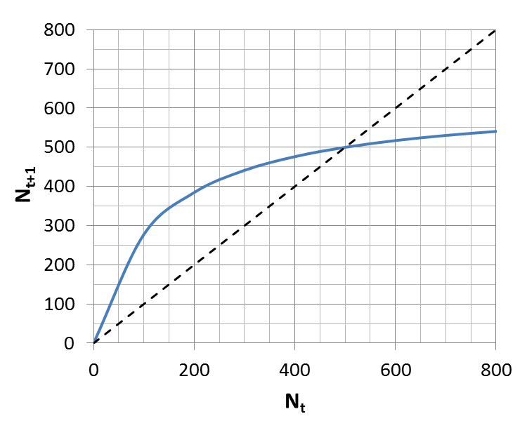
Scramble OR Contest

Allee effects present OR No Allee effects
- (8 pts.) From the following data on the abundance through time of a fish species, rank the age classes from highest to lowest average survival rates. Assume that the survival of age class 3 is unknown. Show your work!

 | Abundance
age class | Year 1 | Year 2 | Year 3
0 | 500 | 400 | 450
1 | 30 | 40 | 20
2 | 30 | 20 | 20
3 | 30 | 25 | 15

- (4 pts.) How many non-zero elements (at most) does the Leslie matrix have for an age-structured population consisting of 2 immature age classes (i.e. not reproducing) and 3 reproductive age classes (so there are 5 age classes total)? Show your work!

- (8 pts.) Construct the Leslie matrix that corresponds to a population having 3 stage classes: larvae, juveniles and adults. Larvae and juveniles have a 0.3 probability of surviving and staying in the same stage, and a 0.4 probability of surviving and moving to the next stage. Adults have a 0.8 probability of surviving, and adults have a per capita adult fecundity of 15 (larvae and juveniles do not have young).

For questions 16, 17, and 18, refer to the following Leslie matrix, which describes an annually-reproducing population consisting of five stages: larvae, small juveniles, large juveniles, small adults, and large adults:

0 | 0 | 0 | 4.0 | 10.0
0.05 | 0.15 | 0 | 0 | 0
0 | 0.20 | 0.25 | 0 | 0
0 | 0 | 0.35 | 0.55 | 0
0 | 0 | 0 | 0.15 | 0.85

- (6 pts.) If there are 200 larvae and 100 small juveniles this year, how many small juveniles will there be next year?

- (6 pts.) What is the probability of a large juvenile surviving and remaining as a large juvenile from one year to the next? (If you make a mistake on a question like this, explaining or showing your reasoning can give partial credit.)

- (6 pts.) If the population currently consists of 100 small adults and 50 large adults, how many larvae will there be in the population next year? Assume that no adults die before reproducing.

- (10 pts.) The following curve is a replacement curve.

- For a starting density of N₀ = 100, draw how the population progresses on the replacement curve (draw right on the figure).

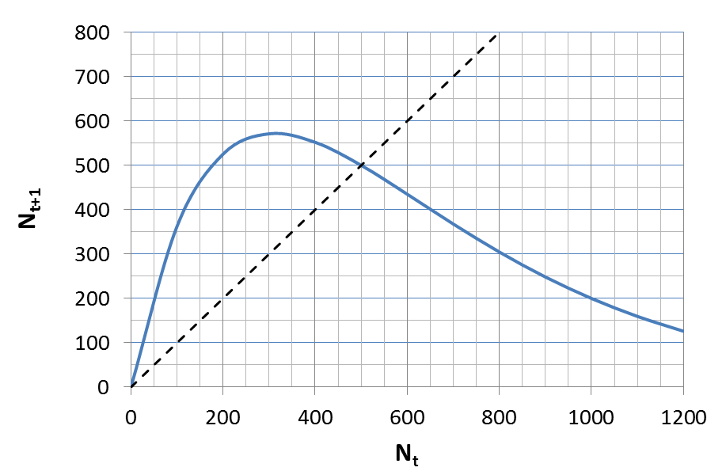

(b) Draw a graph below (on the grid provided) showing how the density changes over time for N₀ = 100. In other words, make a plot of density versus time for the population trajectory you determined on the replacement curve above (you only need to plot from time 0 to time 5). Be sure to provide axis labels as well as numbers for the tick marks. What is the carrying capacity for this population?

Carrying capacity: _________

- (6 pts.) What is the probability of persistence of a metapopulation composed of 4 subpopulations (local populations) which each have an extinction probability of 60%? (Assume subpopulations operate completely independently)

Bonus Questions:

BQ1: (2 pts.) The following Leslie matrix for a stage-structured amphibian population is ecologically impossible. Can you find the offending elements? Explain what the problem is.

0 | 0 | 0 | 25.0
0.02 | 0.45 | 0 | 0
0 | 0.18 | 0.70 | 0
0 | 0 | 0.40 | 0.98

BQ2: (2 pts.) What important (single) parameter can describe the survival and fecundity rates in a Leslie matrix when the population is at the stable age distribution?

