FW364 Spring 2012
Competition Practice Problems

- Exploitative interspecific competition refers to:

- direct competitive interactions within a species
- indirect competitive interactions between species
- indirect competitive interactions within a species
- direct competitive interactions between species

- Draw a SIMPLE conceptual model representing two species resource competition. Note: by simple conceptual model, I am referring to the basic box and arrow diagrams we have used during lecture; I am NOT referring to the complex box and arrow diagrams that we have built in Stella.

- How would we modify the conceptual model from Question 2 if the two consumer species were competing over two shared resources?

- Under the competitive exclusion principle (circle all that apply):

- the consumer with the lowest resource requirement at equilibrium will win
- there can be only one winner of resource competition
- the consumer with the lowest R* will dominate initially
- the consumer with the greatest R* wins

- Which assumptions apply to the following set of equations (circle all that apply)?

${dP_{1}}/{dt}=a_{1}c_{1}RP_{1}- d_{1}P_{1}$ ${dP_{2}}/{dt}=a_{2}c_{2}RP_{2}- d_{2}P_{2}$
$${dR}/{dt}=b_{r}R- d_{r}R-a_{1}RP_{1}- a_{2}{RP}_{2}$$

- in the absence of consumer one, the resources grow exponentially
- consumers encounter prey randomly
- consumers have a satiating (Type II) functional response
- the consumer populations will increase exponentially in the absence of prey
- exploitative competition

- R* for a consumer species is determined by:

- allowing two consumer species to compete over a shared resource and measuring the equilibrium abundance of the resource
- allowing a single consumer species to grow to equilibrium while consuming a single resource and measuring the equilibrium abundance of the consumer
- allowing a single consumer species to grow to equilibrium while consuming two resources and measuring the equilibrium abundance of the resources
- allowing a single consumer species to grow to equilibrium while consuming a single resource and measuring the equilibrium abundance of the resource

- Solve the equation below for R*. What type of functional response does the consumer have in this equation?

$${dP}/{dt}=acRP- d_{p}P$$

- According to the type II functional response equation below, what happens to the feeding rate, f, when the number of resources is high?

$$f=\frac{f_{max}R}{R+h}$$

- f approaches f_{max}
- f approaches zero
- f approaches 1
- f approaches h

- What is the half-saturation constant, h, for the feeding rate curve below if the maximum feeding rate, f_{max}, is 6?

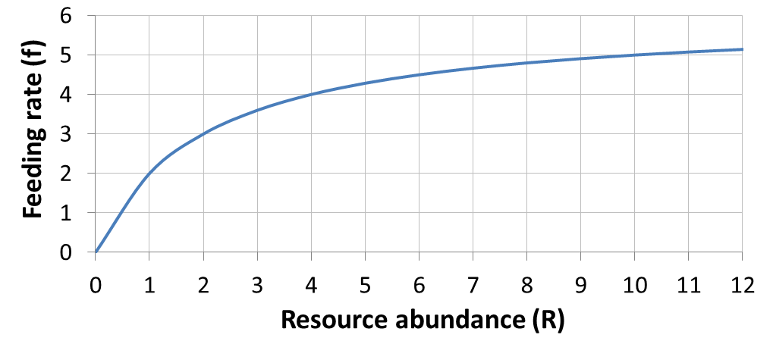

- Solve the equation below for R*. What type of functional response does the consumer have in this equation?

$${dP}/{dt}=\frac{cf_{max}RP}{R+h}- d_{p}P$$

- According to your R* solution for Question 10, which of the below make a better competitor (circle all that apply)?

- competitor with a low feeding rate
- competitor with a high death rate
- competitor with a low half-saturation constant
- competitor with a high conversion efficiency

- What part of the equation in Question 10 represents the consumer birth rate?

- If the solid curve represents the consumer birth rate, and the dashed line represents the consumer death rate, what is R* for the consumer represented in the figure below?
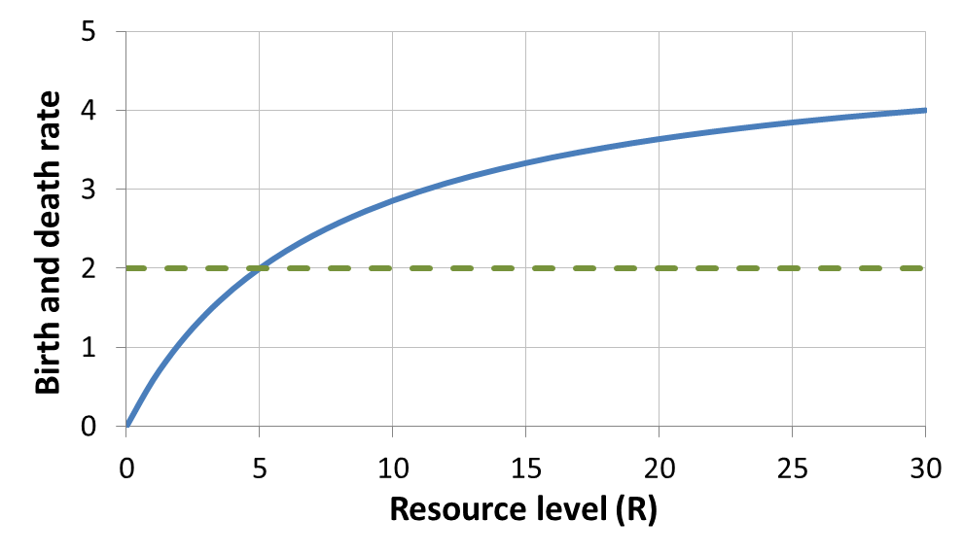
b_{p}
d_{p}

- Use the following figure to answer the questions below.
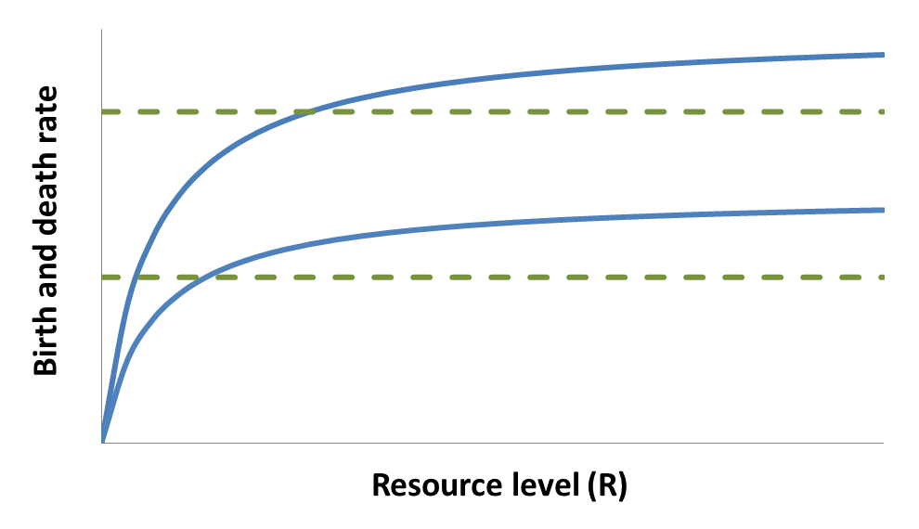
b₁
d₁
d₂
b₂
Assuming that b₁ and b₂ are functions relating the birth rates of two consumer species (1 and 2) to resource abundance, and that d₁ and d₂ are death rate functions:

- Which species will be the winner of competition if the death rate of both species is given by d₁?

- Which species will be the winner of competition if the death rate of both species is given by d₂?

- Circle the correct option from each pair below to describe the characteristics of r- and K-selected species.
K-selected (climax species)

low birth rate vs. high birth rate

low death rate vs. high death rate

low h vs. high h
r-selected (weedy species)

low birth rate vs. high birth rate

low death rate vs. high death rate

low h vs. high h

- Use the following figure to answer the questions below.
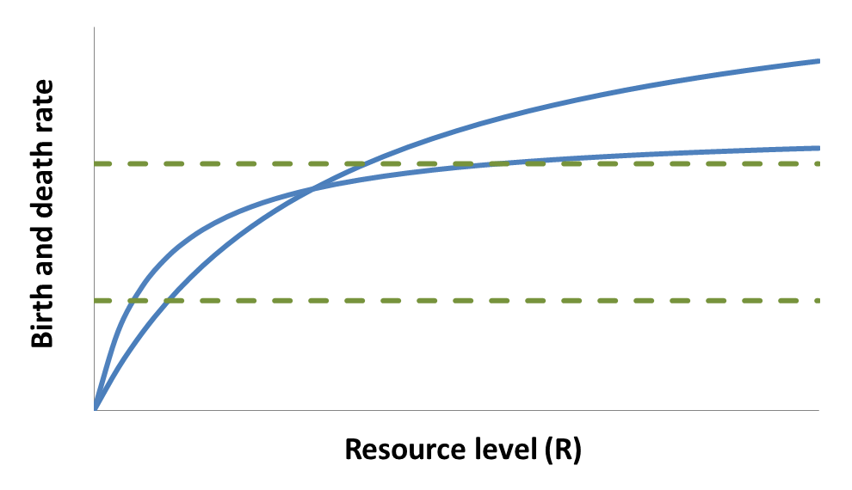
b₂
d₁
d₂
b₁
Assuming that b₁ and b₂ are functions relating the birth rates of two consumer species (1 and 2) to resource abundance, and that d₁ and d₂ are death rate functions:

- Which species will be the winner of competition if the death rate of both species is given by d₁?

- Which species will be the winner of competition if the death rate of both species is given by d₂?

- Which species will be the winner of competition if the death rate of consumer 1 is d₁ and the death rate of consumer 2 is d₂?

- Given the parameters in part c, would consumer 1 represent a weedy species or a climax species?

- The figure below is a competition-disturbance figure, showing how the abundance of two competing species changes through time with multiple disturbance events (black arrows). Does the consumer with the dashed line represent a weedy species or a climax species?
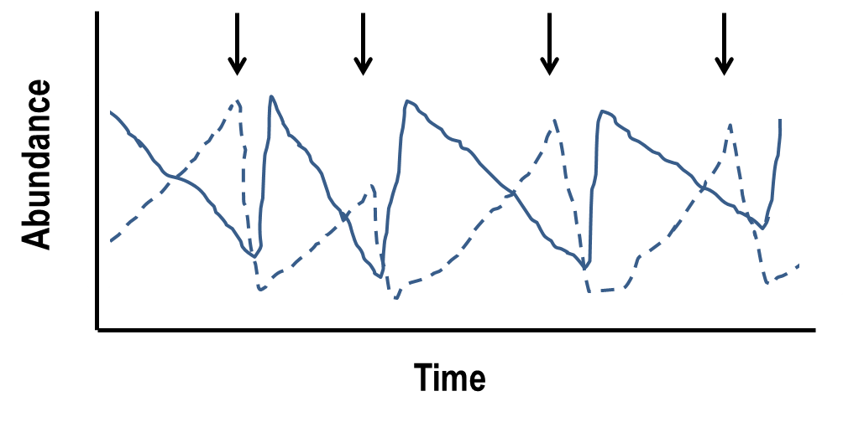

- Which of the following could promote co-existence of competing species, even if one species is a superior competitor for a shared single resource (circle all that apply)?

- harvest of the superior competitor
- periodic disturbances that favor the inferior competitor
- the introduction of a predator species that prefers the inferior competitor
- the inclusion of a second resource for which the inferior competitor (inferior based on the original resource) has a lower R*

- Given one example of an application of competition modeling.

- **This is a challenging question. Be sure to read the questions for parts a-c carefully.
Note: there may be extraneous information provided.**

A resource has a birth rate of 4 individuals per month and a death rate of 2 individuals per month due to non-predatory sources of mortality. The resource is eaten by two consumers that are not aggressive to each other. The conversion efficiency of both consumers is 0.5. Consumer 1 has an attack rate that is 2 times greater than the attack rate of consumer 2. Consumer 1 has a death rate that is 4 times greater than the death rate of consumer 2. Given the equations below, answer the following three questions.

${dP_{1}}/{dt}=a_{1}c_{1}RP_{1}- d_{1}P_{1}$ ${dP_{2}}/{dt}=a_{2}c_{2}RP_{2}- d_{2}P_{2}$
$${dR}/{dt}=b_{r}R- d_{r}R-a_{1}RP_{1}- a_{2}{RP}_{2}$$

- Which consumer has the greater birth rate?

- What is the growth rate of each consumer at equilibrium?

- Does one species drive the other extinct at steady state? If so, which persists and which goes extinct?

