**FW364**

**Final Exam - PRACTICE EXAM - KEY**

**April 2012**

**Calculus Practice Questions**

Refer to the figure below for questions 1 through 3:

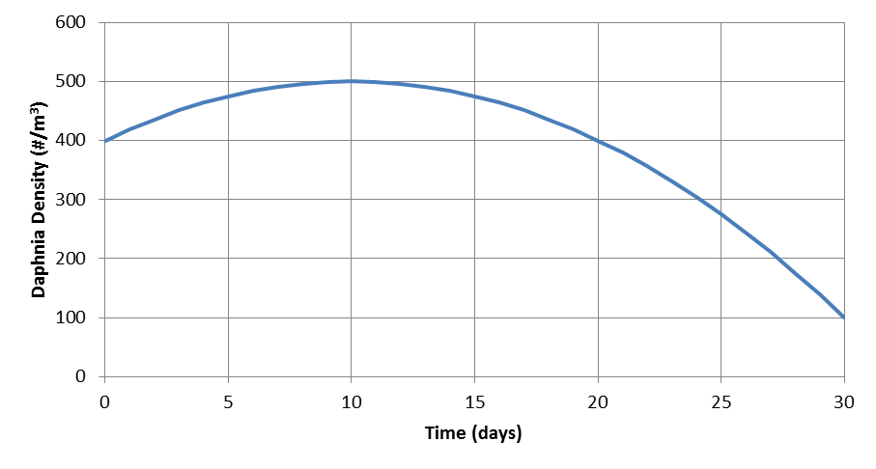

**B**

**A**

1. What is the average population growth rate for the 30 day period?

**To calculate the average population growth rate, draw a line that connects the starting population size (at day 0) to the ending population size (at day 30); this line is represented by the dot-dash line on the figure above. Calculate the slope of the line to determine the average population growth:**

**Slope = rise / run = (100 – 400 *Daphnia* / m3) / (30 – 0 days) = -10 Daphnia / m3 / day**

**Average population growth rate = -10 Daphnia / m3 / day**

1. What is the growth rate at points A and B (using tangent method)?

**To calculate the growth rate at each point, draw a line tangent to the curve at each point (see dashed lines on figure) and calculate the slope of those lines.**

**Point A: Slope = (520 – 420 *Daphnia* / m3) / (10 – 0 days) = 10 *Daphnia* / m3 / day**

**Point B: Slope = (300 – 500 *Daphnia* / m3) / (25 – 15 days) = -20 *Daphnia* / m3 / day**

1. For what days was the (instantaneous) growth rate:

a. negative Days:___**10-30**____

b. positive Days:___**0-10**_____

c. zero? Days:____**10**______

**Predation and Competition Practice Questions**

(Remember for these problems that predator and consumer, victim and prey, and prey and resource can be used interchangeably)

1. Give one reason why ecosystem management is important.

**There are multiple answers to this question, but one of the primary reasons that we discussed in class is:**

**Ecosystem management is important because management models may make incorrect predictions when species linkages are ignored (i.e., single species management models can sometimes make erroneous predictions due to ignoring linkages to other species).**

1. Which of the following statements are true (circle all that apply)?
2. the equilibrium biomass of prey must be greater than the equilibrium biomass of predators
3. territorial predators control prey abundance better than scramble predators
4. **scramble predators control prey abundance better than contest predators**
5. **the net production of the prey must be larger than the net production of the predator**
6. How is prey growth rate linked to predator dynamics?
7. through the prey birth rate
8. through the prey carrying capacity
9. **through a predatory loss term**
10. through the predator death rate
11. How is predator growth rate linked to prey dynamics?
12. **through the predator birth rate**
13. through the prey carrying capacity
14. through the predator death rate
15. through the prey birth rate
16. A predator with a constant attack rate:
17. consumes the same number of prey regardless of prey abundance
18. **consumes the same proportion of the prey population regardless of prey abundance**
19. consumes a smaller proportion of the prey population at high prey abundance
20. none of the above

Refer to the following equation for questions 9 through 12:

$${dV}/{dt}=b_{v}V- d_{v}V-aVP$$

1. The equation above (circle all that apply):
2. describes how prey grow between time 0 and time t
3. **is a differential equation**
4. describes the rate of change in predator abundance
5. **describes the rate of change in prey abundance**
6. Which of the assumptions below apply to the equation above (circle all that apply)?
7. **in the absence of predation, prey grow exponentially**
8. in the absence of predation, prey grow to carrying capacity
9. in the absence of prey, predators decline exponentially
10. **predators encounter prey randomly (i.e., well-mixed environment)**
11. What will be the dynamics of the prey in the absence of predators if bv > dv?
12. monotonic increase to equilibrium
13. **exponential increase**
14. exponential decrease
15. stable limit cycles
16. Solve the equation above for predator abundance at equilibrium.

**Starting equation: ${dV}/{dt}=b_{v}V- d_{v}V-aVP$**

**At equilibrium, *dV/dt* = 0, so $0=b_{v}V^{*}- d_{v}V^{*}-aV^{*}P^{*}$**

**Complete the algebra below to isolate *P\****

🡪🡪

🡪

Refer to the following equation for questions 13 through 16:

$${dV}/{dt}=b_{max}\left(1-V/K\right)V- d_{v}V-aVP$$

1. What type of density dependence do the prey exhibit in the equation above?
2. contest density dependence
3. prey do not exhibit density dependence
4. **scramble density dependence**
5. prey are territorial
6. What will be the dynamics of prey in the absence of predation if V > K?
   1. exponential increase
   2. **decrease to steady state**
   3. exponential decrease
   4. increase to steady state
7. What might *dv* represent in the equation above?
8. prey deaths due to predation
9. **prey deaths due to starvation**
10. predator deaths due to starvation
11. prey births due to consumption of resources
12. When prey abundance is close to zero, which parameter below approximates the prey birth rate?

**a. *bmax***

b. *bp*

c. *a*

d. *c*

1. If an island has 200 prey and 20 predators, and each predator consumes 2 percent of the prey population per day, what is the predator feeding rate (assuming the predators have a type I functional response)?

**Givens:**

***V* = 200 prey**

***P* = 20 predators (note: the predator abundance in unnecessary information)**

***a* = 0.02 per predator per day**

**Predator feeding rate (with type I functional response) = *aV***

**Predator feeding rate = 0.02 per predator per day * 200 prey**

**Predator feeding rate = 4 prey per predator per day**

Refer to the following equation for questions 18 and 19:

$${dP}/{dt}=acVP-d_{p}P$$

1. Which of the assumptions below apply to the equation above (circle all that apply)?
2. **predators consume the same proportion of the prey population regardless of prey abundance**
3. **in the absence of prey, predators decline exponentially**
4. **predators exhibit scramble competition**
5. **predators encounter prey randomly (i.e., well-mixed environment)**
6. Solve the equation above for the prey abundance at equilibrium.

**Starting equation: ${dP}/{dt}=acVP- d_{p}P$**

**At equilibrium, *dP/dt* = 0, so $0=acV^{*}P^{*}- d_{p}P^{*}$**

**Complete the algebra below to isolate *V\****

🡪🡪

🡪

1. Using the equation for prey abundance at equilibrium you derived in question 19, and given the parameters below, how many prey will there be at equilibrium?

*a* = 0.05 per predator per day

*c* = 0.40

*P* = 123 predators

*d*p = 0.10 per day

**Plug values for *a*, *c*, and *d*p above into the *V*\* equation from the solution to question 19 (note: the abundance of the predators, *P*, is unnecessary information):**

🡪 **🡪 *V*\* = 5 prey**

1. The attack rate of a consumer can be converted to a (Type I) feeding rate by:
2. multiplying by the number of consumers
3. **multiplying by the number of resources**
4. multiplying by conversion efficiency
5. multiplying by the half-saturation constant
6. The per capita birth rate of a predator is simply its feeding rate multiplied by its:
7. assimilation efficiency
8. half-saturation constant
9. number of prey consumed
10. **conversion efficiency**
11. If the proportion of the prey population a predator consumes per time declines with prey density, the predator must exhibit (circle all that apply):
12. a Type I functional response
13. **a Type II functional response**
14. a linear functional response
15. **feeding saturation**
16. Which of the lines on the figure below (line 1 or 2) most likely depicts the response of plant abundance to an increase in soil fertility (starting at time 5) in an ecosystem where herbivores are not territorial?



**Line 1 - plant abundance returns to pre-fertilization level with non-territorial (i.e., scramble) herbivore**

1. A honey badger and a jackal fighting over a carcass is an example of:
   1. interspecific exploitative competition
   2. intraspecific interference competition
   3. **interspecific interference competition**
   4. intraspecific exploitative competition
2. What equation might the Stella conceptual model below represent?

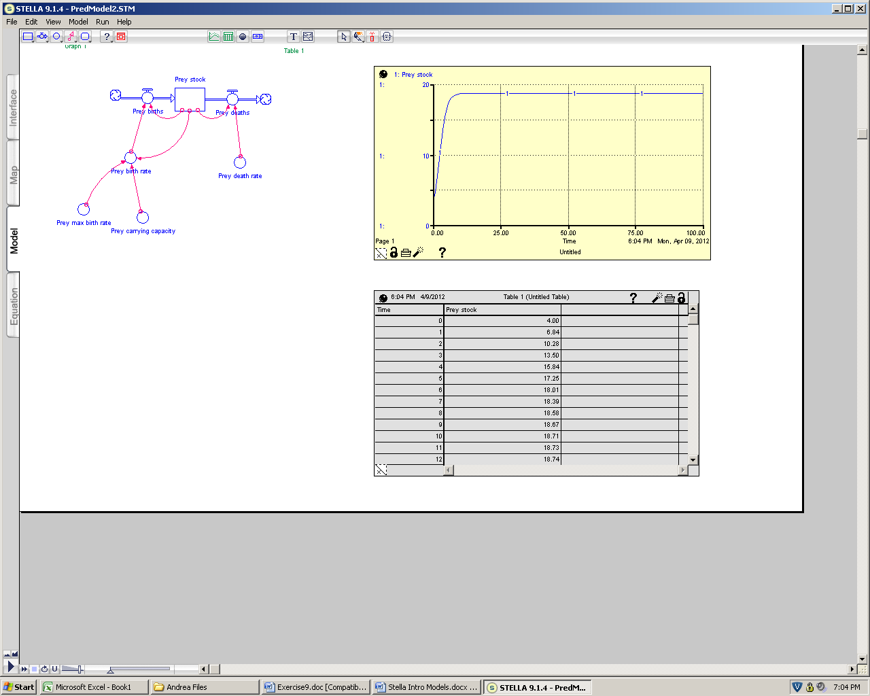

1. equation for unregulated exponential prey growth
2. equation for predator growth with contest density dependence
3. **equation for prey growth with scramble density dependence**
4. equation for prey growth with contest density dependence
5. The equations below represent what type of competition, assuming the two consumers are different species?

${dP_{1}}/{dt}=a_{1}c_{1}RP_{1}- d_{1}P_{1}$ ${dP_{2}}/{dt}=a_{2}c_{2}RP_{2}- d_{2}P_{2}$

$${dR}/{dt}=b_{r}R- d_{r}R-a_{1}RP_{1}- a_{2}{RP}_{2}$$

1. **interspecific exploitative competition**
2. interspecific interference competition
3. intraspecific interference competition
4. intraspecific exploitative competition
5. Which of the equations and/or parameters below might represent a predator (consumer) feeding rate (circle all that apply)?
6. ***aV***
7. ***f***

**All might represent a predator (consumer) feeding rate**

1. ***aR***
$\frac{f_{max}R}{R+h}$

3. Which of the equations and/or parameters below might represent a predator (consumer) birth rate (circle all that apply)?
4. ***caR***
5. ***bp***

**All might represent a predator (consumer) birth rate**

1. ***cf***
$\frac{{cf}_{max}R}{R+h}$

3. Which of the following could promote co-existence of a weedy (i.e., species with high birth rate at high resources levels but high R*) and climax (i.e., species with low birth rate at high resource levels but low R*) plant species (circle all that apply)?
4. **periodic disturbances**
5. the introduction of an herbivore that prefers the weedy species
6. **regular fertilization of the environment**
7. **harvest of the climax species**
8. Which of the characteristics below make a consumer a better competitor (circle all that apply)?
   1. **high birth rate**
   2. **low death rate**
   3. low feeding rate
   4. high half saturation constant
9. Under the competitive exclusion principle we assume (circle all that apply):
10. competitors are equivalent in their R*
11. **competition occurs over a single resource**
12. **a stable environment**
13. competition leads to coexistence

Use the following equations and figure to answer questions 33 and 34 below:

$${dV}/{dt}=b_{v}V-d_{v}V-\frac{f_{max}VP}{V+h}$$

$${dP}/{dt}=\frac{cf_{max}VP}{V+h}-d_{p}P$$

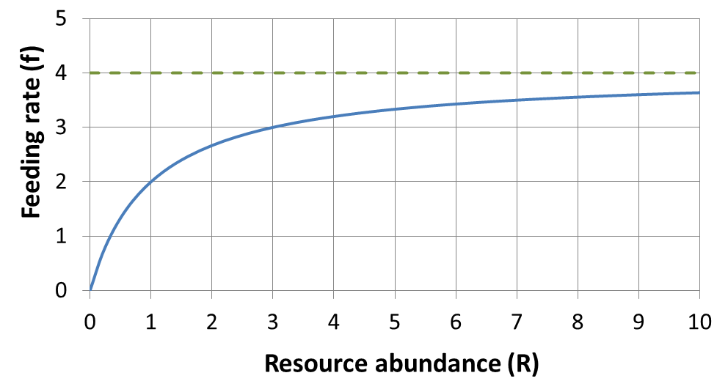

***h***

***fmax***

1. What is the meaning (i.e., definition) of *fmax* in the equations above? On the figure above, draw a line that represents *fmax*, assuming *fmax* = 4.

***fmax* is the maximum feeding rate of the consumer, which occurs at high resource density.**

**The dashed line on the figure above represents *fmax*.**

1. What is the meaning (i.e., definition) of *h*? Determine *h* for the consumer species represented in the figure above.

***h* is the consumer half saturation coefficient. Specifically, *h* is the value of *R* (i.e., resource abundance) when the feeding rate is half of the maximum value.**

**If *fmax* = 4, then *h* is the resource abundance when *f* = 2.**

**The resource abundance equals 1 when *f* = 2, so *h* = 1 resource**

1. Use the following figure to answer the questions below.

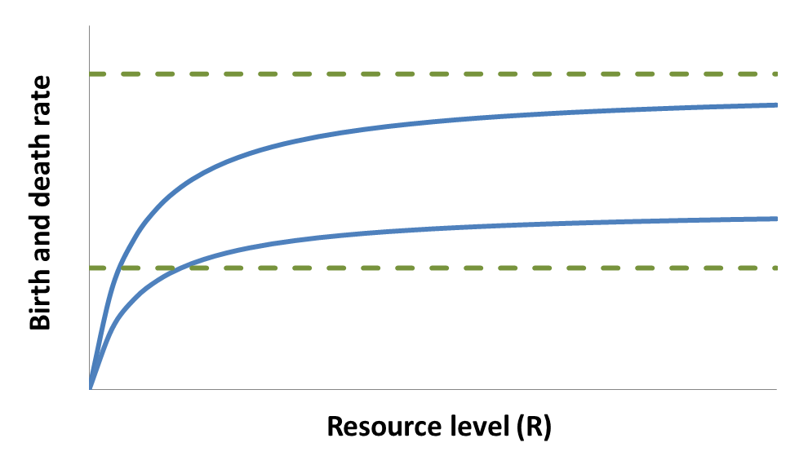

*b*1

*d*1

*d*2

*b*2

*R*1*

*R*2*

Assuming that *b*1 and *b*2 are functions relating the birth rates of two consumer species (1 and 2) to resource abundance, and that *d*1 and *d*2 are death rate functions:

1. Which species will be the winner of competition if the death rate of both species is given by *d*1?

**Trick question! The death rate, *d*1, is above the birth rate functions for both consumers, so both consumers will go extinct.**

1. Which species will be the winner of competition if the death rate of both species is given by *d*2?

**R* for each species occurs where the birth rate curves and death rate line intersect (i.e., when *b* = *d*, which indicates steady state). The death rate, *d*2, intersects the birth rate curves for both consumers. The intersection for consumer 1 corresponds to a lower resource abundance (i.e., lower R*) than consumer 2, so consumer 1 will be the winner.**

1. Use the following figure to answer the questions below.

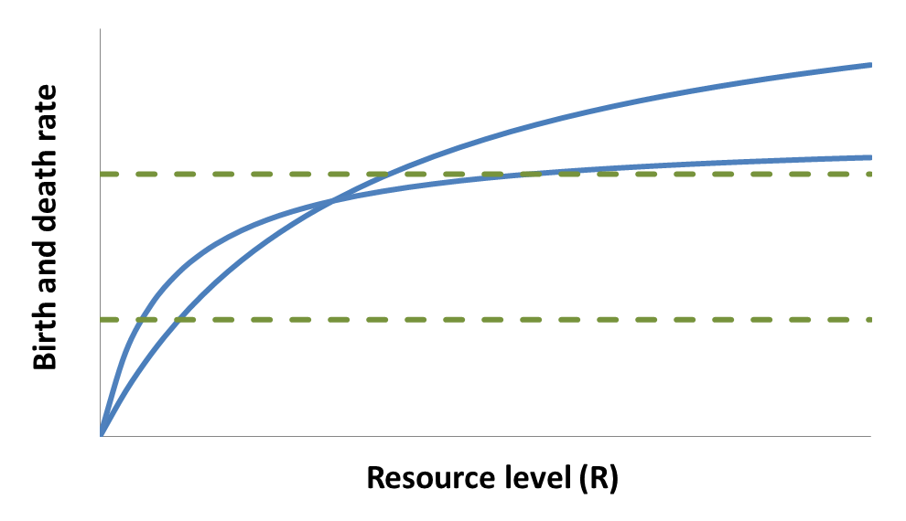

*R*1*

*R*2*

*R*1*

*R*2*

*b*2

*d*1

*d*2

*b*1

Assuming that *b*1 and *b*2 are functions relating the birth rates of two consumer species (1 and 2) to resource abundance, and that *d*1 and *d*2 are death rate functions:

1. Which species will be the winner of competition if the death rate of both species is given by *d*1?

**At the death rate depicted by *d*1, consumer 1 will win (*R*1* < *R*2*); see points above.**

1. Which species will be the winner of competition if the death rate of both species is given by *d*2?

**At the death rate depicted by *d*2, consumer 2 will win (*R*2* < *R*1*); see points above.**

1. Based on your answers to parts a and b above, which species will be favored by a higher death rate and **why** will that species be favored?

**Consumer 1 will be favored by a higher death rate; consumer 1 has a higher maximum birth rate and so can withstand a higher death rate without going extinct.**

1. Which species will be the winner of competition if the death rate of consumer 1 is *d*1 and the death rate of consumer 2 is *d*2?

**With the death rate depicted by *d*1 for consumer 1 and *d*2 for consumer 2,**

**consumer 2 will win (*R*2* < *R*1*).**

1. Might consumer 1 represent a weedy species or a climax species?

**Consumer 1 has a (relatively) higher birth rate and higher half-saturation constant, and so consumer 1 would be a weedy species.**

1. Given the equation below for *R*\*, match the following four cases with the graph that most likely describes the dynamics of the two competing consumer species. **Hint**: Calculate *R*\* for every species as a first step toward answering this question.

$$R^{*}=\frac{d_{p}h}{cf_{max}-d_{p}}$$

|  |  |  |  |  |  |  |  |  |
| --- | --- | --- | --- | --- | --- | --- | --- | --- |
|  | **Case 1** | | **Case 2** | | **Case 3** | | **Case 4** | |
| **Parameter** | **Species 1** | **Species 2** | **Species 1** | **Species 2** | **Species 1** | **Species 2** | **Species 1** | **Species 2** |
| *fmax* | 2.0 | 1.0 | 1.6 | 2.0 | 2.0 | 1.6 | 1.0 | 2.2 |
| *h* | 1.0 | 1.0 | 1.0 | 1.0 | 1.0 | 1.0 | 1.0 | 1.0 |
| *c* | 0.5 | 0.5 | 0.5 | 0.5 | 0.5 | 0.5 | 0.5 | 0.5 |
| *dp* | 0.5 | 0.2 | 0.3 | 0.2 | 0.2 | 0.2 | 0.2 | 0.5 |
| ***R\**** | **1.00** | **0.67** | **0.60** | **0.25** | **0.25** | **0.33** | **0.67** | **0.83** |

 

**Time**

**Abundance**

**Abundance**

**Time**

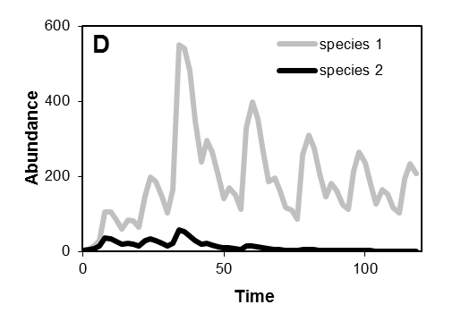

**Time**

**Abundance**

**Abundance**

**Time**

**The best way to approach this question is to first calculate R* for each species for each case (see last line of table above). This allows you to narrow down choices for each case based on the competition winner (just based on R*, Cases 1 and 2 could be B or C, and Cases 3 and 4 could be A or D). Then, for the species pair for each case, determine which species has the highest *fmax*; this species will grow the fastest at first (since *bp* = *f* * *c*, and all consumers have the same *c* for this question, then *fmax* will determine how quickly consumers grow initially). Use this information to narrow down the two choices remaining for each case. The correct answers are:**

**Case 1 = B Case 3 = D**

**Case 2 = C Case 4 = A**