FW364 Name: _______________________
Midterm I Exam
February 15, 2012 Section: ______________________

Be sure to read questions carefully. Always give the best answer.
Pay attention to units in the questions and in your answers. Show your work.

1. (4 pts.) Which of the following is a measure of the net production of a plant population?

a. photosynthesis
b. respiration
c. photosynthesis minus respiration
d. photosynthesis plus respiration

2. (4 pts.) Given the units of a stock in the global hydrologic cycle, which of the following represents the best example of a flow into the stock of water in the world’s oceans?

a. evaporation (m³/yr)
b. precipitation (m/yr)
c. precipitation (m³/yr)
d. evaporation (m/yr)

3. (4 pts.) Environmental stochasticity affects:

a. only small populations
b. only large populations
c. all populations, regardless of size
d. only populations that reproduce seasonally

4. (4 pts.) What is the tripling time of a population that is growing geometrically? Show
derivation assuming discrete growth.

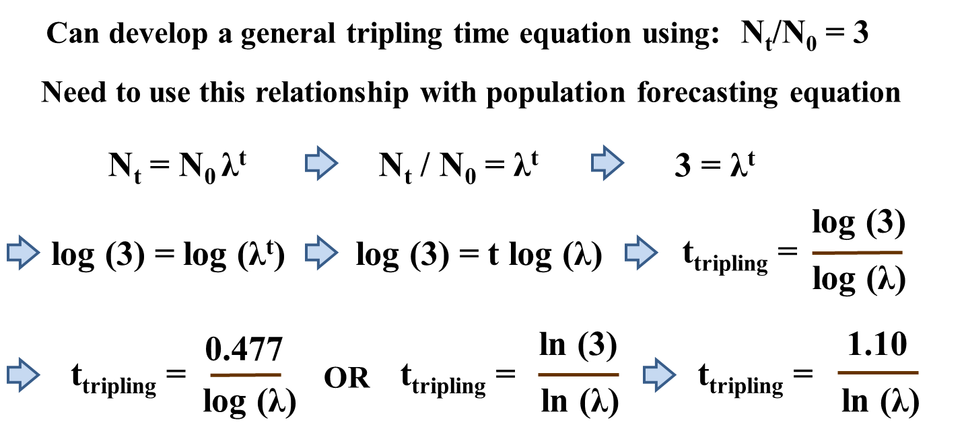
5. (4 pts.) If we wanted to determine the residence time of water in Lake Michigan at steady state, and we knew the total of all river and groundwater flowing into the lake annually, what other information would we need?

a. the volume of precipitation falling onto the lake annually and the surface area of the lake
b. the volume of water evaporating from the lake annually and the surface area of the lake
c. the surface area of the lake and the volume of the lake
d. the volume of precipitation falling onto the lake annually and the volume of the lake

6. (6 pts.) The equation: N_{t} = N₀λ^{t} is an example of which type of model? (choose between each pair, circle the right choice):

static or dynamic

deterministic or stochastic

7. (4 pts.) Which of the following best describes demographic stochasticity?

a. small populations with different probabilities of birth and death grow at different rates
b. population growth is a function of fractional birth and death rates
c. small populations with the same probabilities of birth and death grow at different rates
d. small populations with the same probabilities of birth and death grow at the same rate

8. (4 pts.) The two figures below are risk curves. Label each figure as either an extinction risk curve or explosion risk curve. Give an example of the type of organism (does not have to be a specific species) that each curve might be useful for managing.

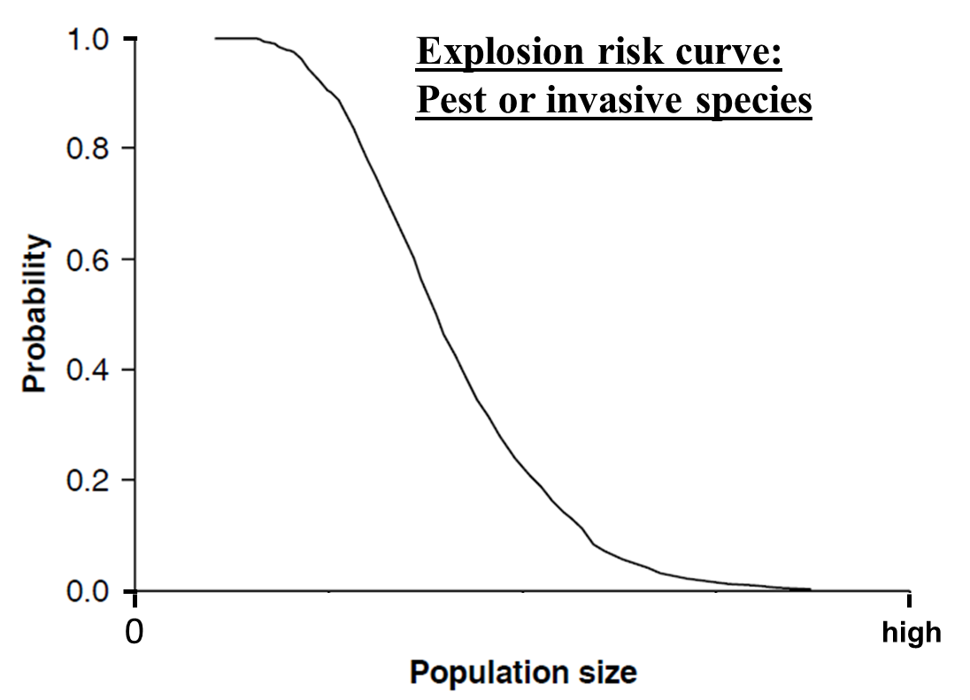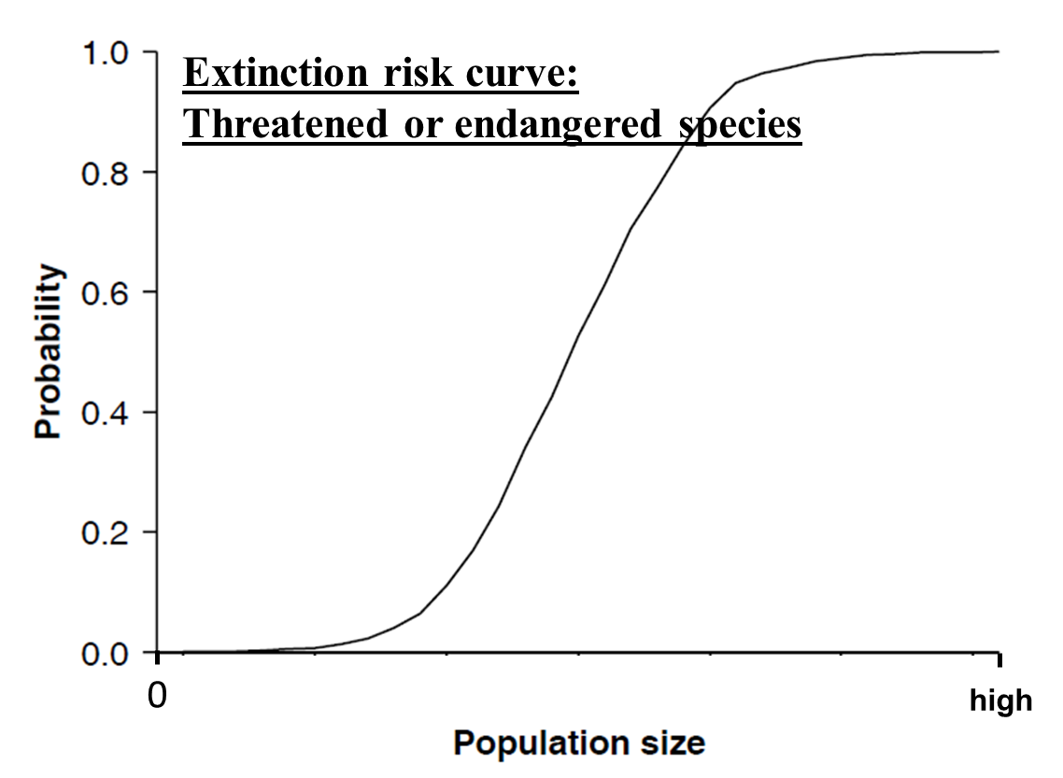
9. (6 pts.) To derive our equations for population growth, a main assumption about the birth rate
of the population was made.

(a) What was this main assumption?

The main assumption was that the per capita birth rate was linear: B = b’N

(b) Use a graph to illustrate the assumption (make sure to label axes).

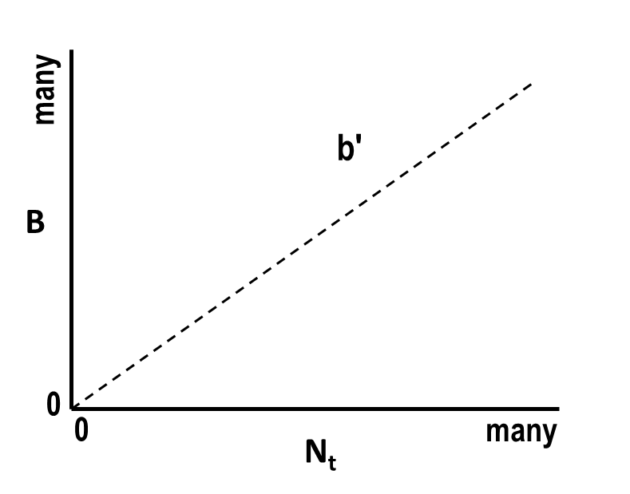

10. (8 pts.) Create a complete diagram that illustrates the cycling of carbon in a closed ecosystem comprised of the following four stocks: plant carbon, herbivore carbon, detrital carbon and CO₂. Label the diagram with words that describe each flow process.

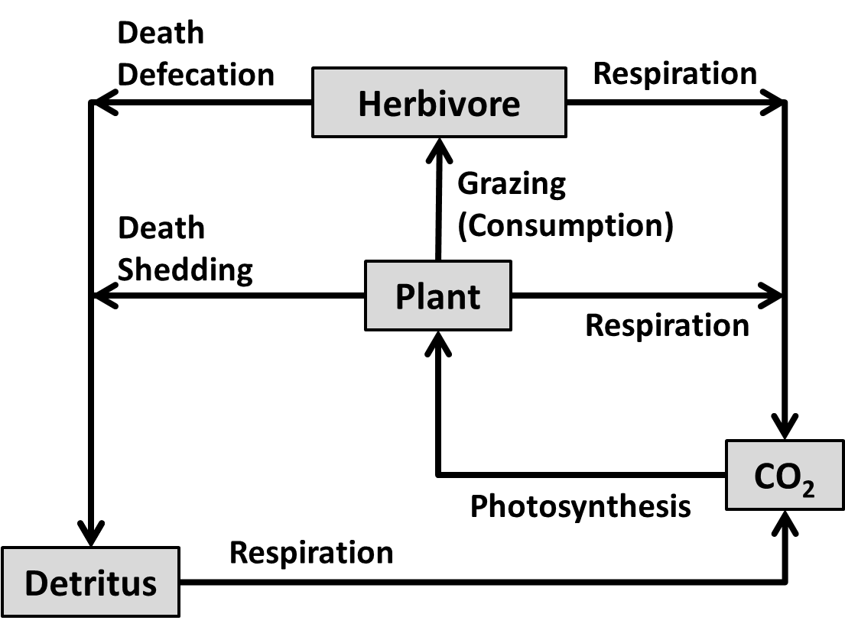

11. (4 pts.) Which of the following is the correct formula for determining the ratio of herbivore carbon to plant carbon (S_{H}/S_{P})?

a. (T_{H}•F_{P})/(T_{P}•F_{H})
b. (T_{H}•F_{H})/(T_{P}•F_{P})
c. (T_{P}•F_{H})/(T_{H}•F_{P})
d. (T_{P}•F_{P})/(T_{H}•F_{H})
12. (4 pts.) Imagine two wildlife biologists (Liz and Mike) forecasting the population dynamics of migratory geese. Liz defines her study population as all birds inhabiting North America, while Mike defines his study population as all birds inhabiting Ingham County. What additional processes (parameters) does Mike need in his population-forecasting model that
Liz probably doesn't need?

Immigration and emigration

13. (4 pts.) The following is a partial table of results from 200 replications of a stochastic model that was used to forecast next year's population size. Note that 95 individuals was the minimum forecasted.

Population size | # of trials | Cumulative | Prob to decline to N_{c}
95 | 5 | 5 | 0.025
96 | 5 | 10 | 0.050
97 | 10 | 20 | 0.100
98 | 10 | 30 | 0.150
99 | 15 | 45 | 0.225
100 | 15 | 60 | 0.300
101 | 20 | 80 | 0.400
102 | 25 | 105 | 0.525

What is the probability of population size being 100 or fewer individuals next year?

(5 + 5 + 10 + 10 + 15 + 15)/200 = 60/200 = 0.30 (30%)

14. (5 pts.) Your bathtub has a volume of 400 liters. If you adjust the faucet to deliver 1.666 liters per minute, plug the drain at 7PM and forget about it, what time will it be when the bathroom floor starts getting wet?

The time it takes for the bathtub to completely fill is the residence time (T)
T = S/F
S = 400 L
F = 1.666 L/min
T = 400 L/(1.666 L/min) = 240 min = 4 hours
It will be 11 PM (4 hours after 7 PM) when the floor starts getting wet
15. (8 pts.) The average trout consumes 10g of carbon per day, assimilates 60% of what it consumes and incorporates 30% of what it assimilates. If there are 100 trout in the population, what are the gross and net production rates of this population?

gross production is assimilation rate
net production is incorporation rate

Each trout assimilates 10 gC/day x 0.60 = 6 gC/day
Gross production of the trout population is: 6 gC/trout/day x 100 trout = 600 gC/day

Each trout incorporates 10 gC/day x 0.60 x 0.30 = 1.8 gC/day
Net production of the trout population is: 1.8 gC/trout/day x 100 trout = 180 gC/day

16. (8 pts.) Lake Wymea has a surface area of 200,000 m² and a water residence time of 200 days. If the total volume of the lake is 480,000 m³ at steady-state, and groundwater plus river flow into the lake is 75 m³/hr, what is the rate of precipitation onto the lake surface in m/day?

T = S/F, so F = S/T, where S = 480,000m³ and T = 200days
F = 480,000m³/200days = 2400m³/day = total input (F_{i})

total input is the sum of runoff volume (75 m³/hr = 1800m³/day) and precipitation volume (P)

F_{i} = 2400m³/day = 1800m³/day + P
P = 2400m³/day - 1800m³/day = 600 m³/day

The volume input of precipitation is equal to the precipitation rate (p, m/day) multiplied by the lake's surface area (SA):

P = p * SA,

p = P/SA = = 0.003m/day

17. (6 pts.) Write an equation that forecasts population size next year (N_{t+1}) as a function of: population size this year (N_{t}), a constant per capita birth rate (b'), a constant per capita death rate (d'), a constant number harvested per year (H) and a constant number of immigrants per year (I).

N_{t+1} = N_{t}(1 + b' - d') - H + I

18. (8 pts.) A salmon population has a per capita death rate from natural causes of 4% per year, a per capita death rate from harvesting of 6% per year, and a per capita birth rate of 8% per year. Assuming the population is closed, how many salmon will there be in 100 years if current population size is 100,000 fish?

N_{t} = N₀λ^{t}, where N₀ = 100,000 and t = 100 years
λ = 1 + birth rate - death rate - harvest rate
λ = 1 + 0.08 - 0.04 - 0.06 = 0.98 (so the population will decline)

N_{t} = 100,000(0.98¹⁰⁰) = 13,262 salmon

19. (5 pts.) A population of elk at steady-state has a per capita birth rate of 0.15 and a per capita emigration rate of 0.05. If there is no immigration into this population, what is the per capita death rate? What is λ?

λ = 1, since population is at steady state
λ = 1 + birth rate - emigration rate - death rate
death rate = 1 + birth rate - emigration rate - λ
death rate = 1 + 0.15 - 0.05 - 1 = 0.10

Bonus Questions:

BQ1. (1 pt.) What is the equation that describes continuous growth of a population between any
two time periods (i.e., between a starting time and any time in the future)?

N_{t} = N₀ e^{rt}

BQ2. (1 pt.) A population of Paramecium (a genus of protozoa) grows continuously and has an
instantaneous population growth rate of 0.55 per day. What is the doubling time for
Paramecium?

