Lab 9: Predation – Stella Models

PredModel1 - Prey exponential growth

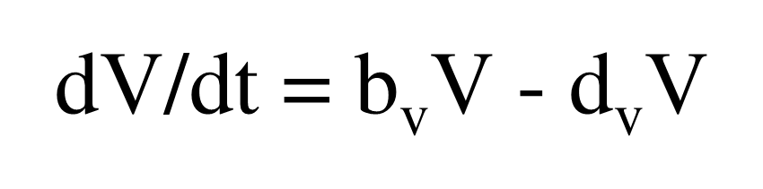
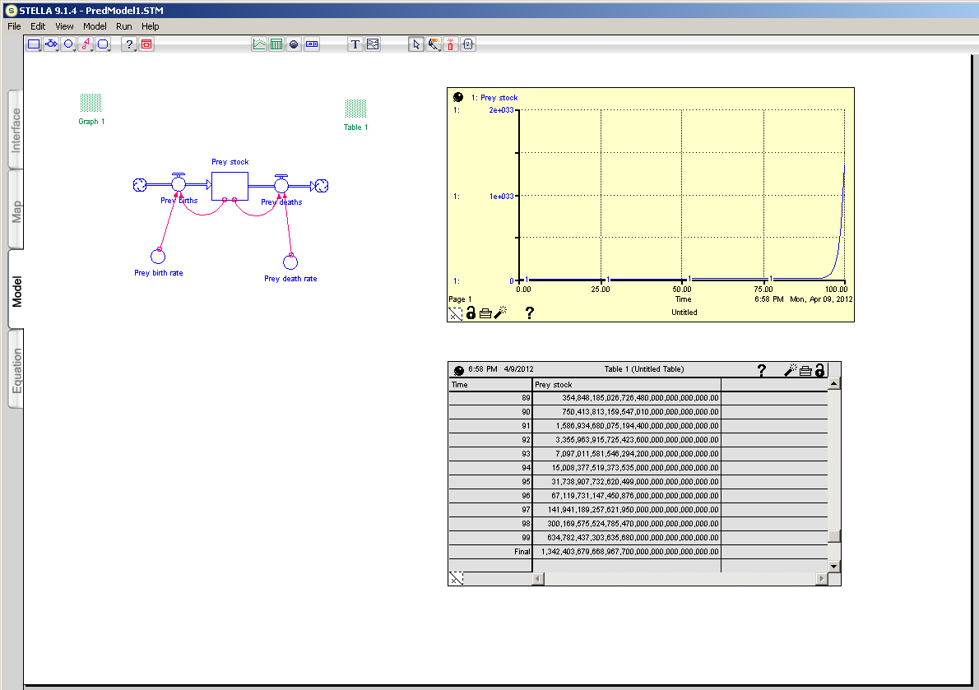

PredModel1 - Prey exponential growth - Equations

Prey_stock(t) = Prey_stock(t - dt) + (Prey_births - Prey_deaths) * dt
INIT Prey_stock = 4
INFLOWS:
Prey_births = Prey_birth_rate*Prey_stock
OUTFLOWS:
Prey_deaths = Prey_death_rate*Prey_stock
Prey_birth_rate = 0.8
Prey_death_rate = 0.05

Notes:
Prey grow exponentially

PredModel2 - Prey density dependent growth

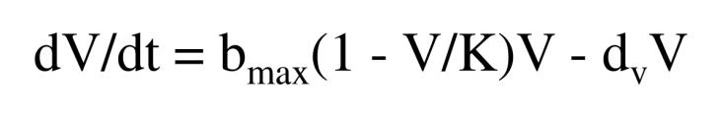
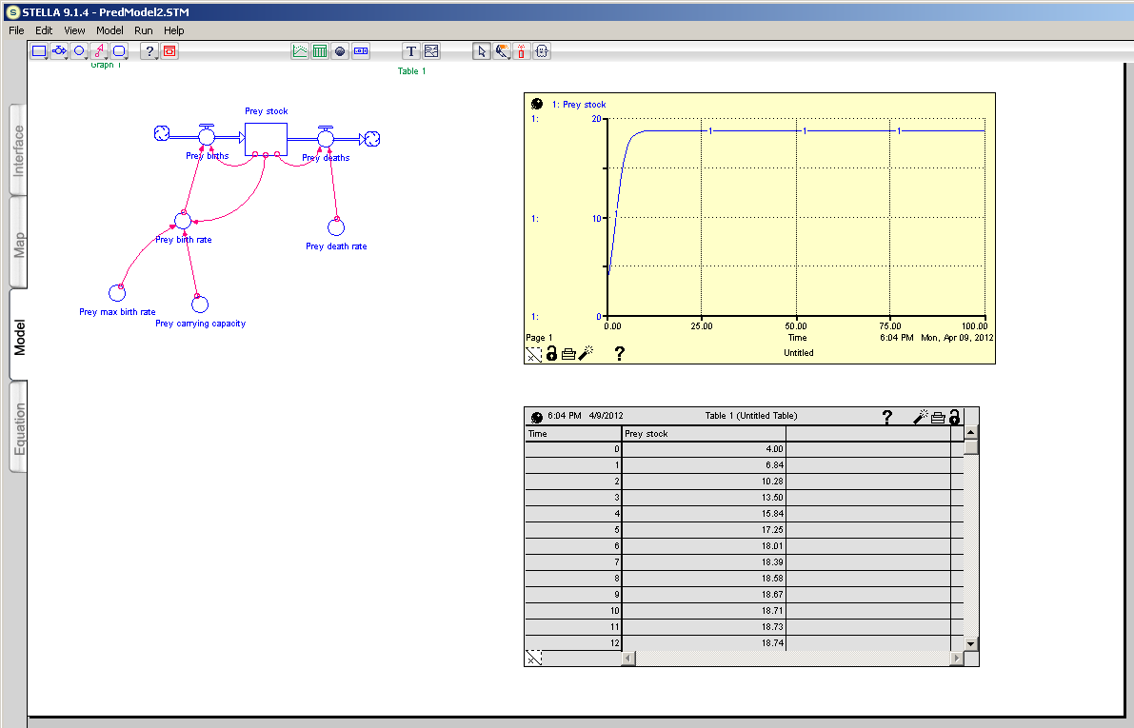

PredModel2 - Prey density dependent growth - Equations

Prey_stock(t) = Prey_stock(t - dt) + (Prey_births - Prey_deaths) * dt
INIT Prey_stock = 4
INFLOWS:
Prey_births = Prey_birth_rate*Prey_stock
OUTFLOWS:
Prey_deaths = Prey_death_rate*Prey_stock
Prey_birth_rate = Prey_max_birth_rate*(1-(Prey_stock/Prey_carrying_capacity))
Prey_carrying_capacity = 20
Prey_death_rate = 0.05
Prey_max_birth_rate = 0.80

Notes:
Prey grow to equilibrium abundance (V*) in the absence of predation
IMPORTANT: V* (=18.75) is not the same as carrying capacity (=20)!

Start with: ${dV}/{dt}=b_{max}\left(1-\frac{V}{K}\right)V-d_{v}V$

Set equation equal to 0: $0=b_{max}\left(1-\frac{V^{*}}{K}\right)V^{*}-d_{v}V^{*}$

Move prey deaths to other side of equation: $d_{v}V^{*}=b_{max}\left(1-\frac{V^{*}}{K}\right)V^{*}$

Cancel V*: $d_{v}=b_{max}\left(1-\frac{V^{*}}{K}\right)$

Distribute b_{max}: $d_{v}=b_{max}-\frac{b_{max }V^{*}}{K}$

Rearrange components: $\frac{b_{max }V^{*}}{K}= b_{max}-d_{v}$

Multiply both sides by K: $b_{max}V^{*}= K\left(b_{max}-d_{v}\right)$

Divide both sides by b_{max}: $\frac{b_{max}V^{*}}{b_{max}}= \frac{K\left(b_{max}-d_{v}\right)}{b_{max}}$

Result: $V^{*}= \frac{K\left(b_{max}-d_{v}\right)}{b_{max}}$

After simplifying: $V^{*}= K\left(1-\frac{d_{v}}{b_{max}}\right)$

Plug in parameters: $V^{*}= 20*\left(1-\frac{0.05}{0.80}\right)=18.75$

PredModel3 - Prey density dependent growth with scramble predator

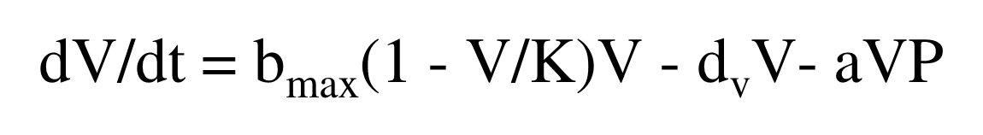
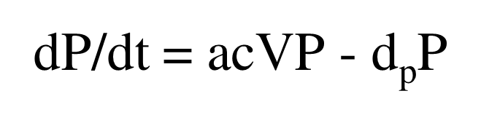
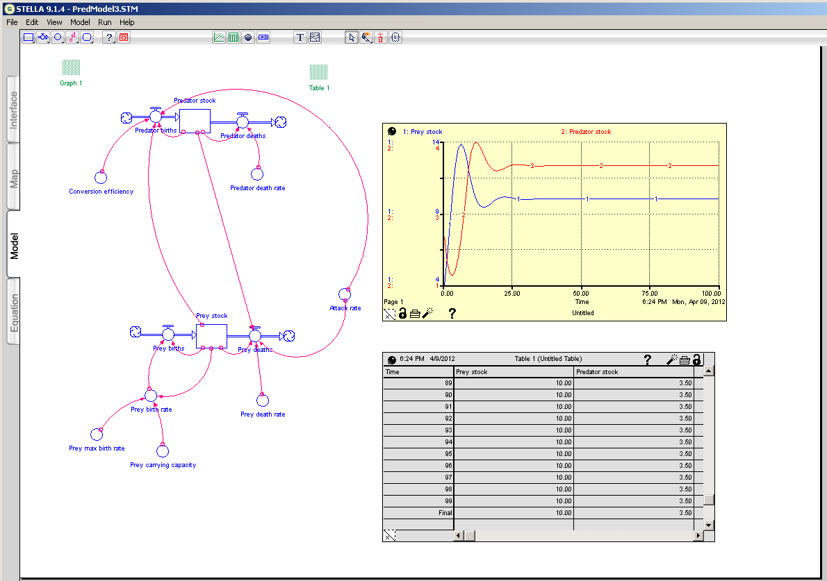

PredModel3 - Prey density dependent growth with scramble predator - Equations

Predator_stock(t) = Predator_stock(t - dt) + (Predator_births - Predator_deaths) * dt
INIT Predator_stock = 2
INFLOWS:
Predator_births = Attack_rate*Conversion_efficiency*Prey_stock*Predator_stock
OUTFLOWS:
Predator_deaths = Predator_death_rate*Predator_stock
Prey_stock(t) = Prey_stock(t - dt) + (Prey_births - Prey_deaths) * dt
INIT Prey_stock = 4
INFLOWS:
Prey_births = Prey_birth_rate*Prey_stock
OUTFLOWS:
Prey_deaths = Prey_death_rate*Prey_stock+Attack_rate*Prey_stock*Predator_stock
Attack_rate = 0.1
Conversion_efficiency = 0.6
Predator_death_rate = 0.6
Prey_birth_rate = Prey_max_birth_rate*(1-(Prey_stock/Prey_carrying_capacity))
Prey_carrying_capacity = 20
Prey_death_rate = 0.05
Prey_max_birth_rate = 0.80

Notes:
Prey and predators grow to equilibrium abundances (V* and P*)
See Part A of Lab 9 for calculations

PredModel4 - Prey density dependent growth with contest predator

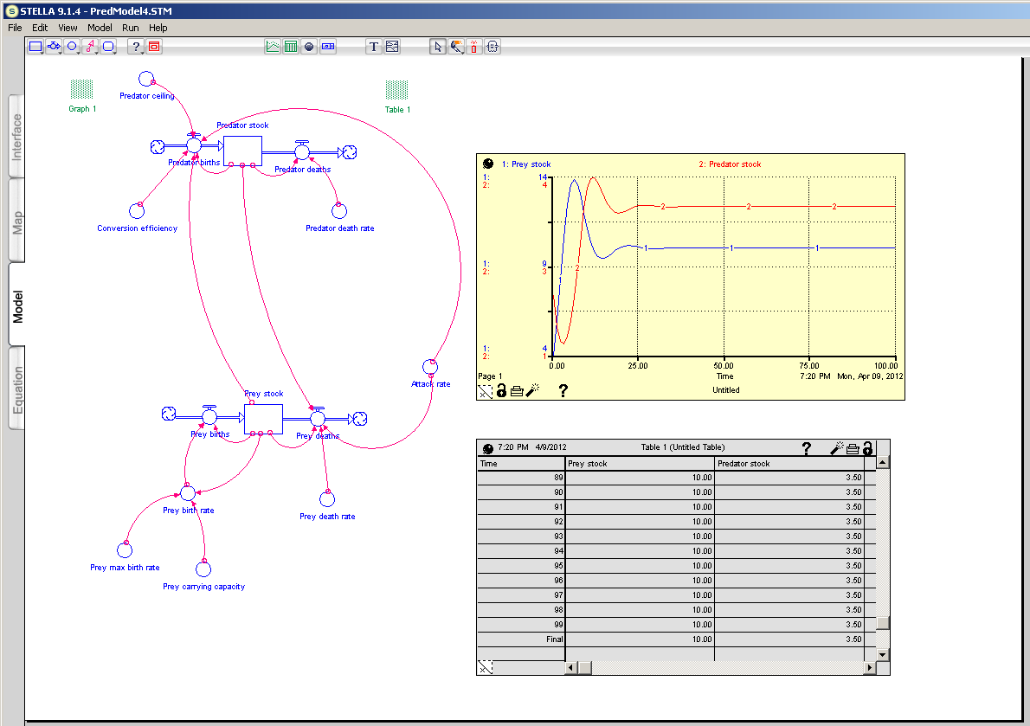

PredModel4 - Prey density dependent growth with contest predator

Predator_stock(t) = Predator_stock(t - dt) + (Predator_births - Predator_deaths) * dt
INIT Predator_stock = 2
INFLOWS:
Predator_births = IF(Predator_stock<Predator_ceiling) THEN (Attack_rate*Conversion_efficiency*Prey_stock*Predator_stock) ELSE (0)
OUTFLOWS:
Predator_deaths = Predator_death_rate*Predator_stock
Prey_stock(t) = Prey_stock(t - dt) + (Prey_births - Prey_deaths) * dt
INIT Prey_stock = 4
INFLOWS:
Prey_births = Prey_birth_rate*Prey_stock
OUTFLOWS:
Prey_deaths = Prey_death_rate*Prey_stock+Attack_rate*Prey_stock*Predator_stock
Attack_rate = 0.1
Conversion_efficiency = 0.6
Predator_ceiling = 5
Predator_death_rate = 0.6
Prey_birth_rate = Prey_max_birth_rate*(1-(Prey_stock/Prey_carrying_capacity))
Prey_carrying_capacity = 20
Prey_death_rate = 0.05
Prey_max_birth_rate = 0.80

Notes:
Prey and predators grow to equilibrium abundances (V* and P*)
See Part A of Lab 9 for calculations
Note: With prey carrying capacity = 20, predators equilibrium abundance (=3.5) is less than predator ceiling

