FW364 Spring 2012
Predation Practice Problems

Refer to the figure below for questions 1 through 3:

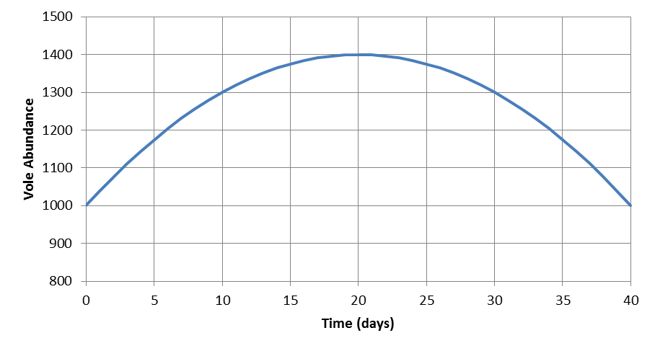
B
A

- What is the average population growth rate for the 40 day period?

- What is the growth rate at points A and B (using tangent method)?

- For what days was the (instantaneous) growth rate:

a. negative Days:__________

b. positive Days:__________

c. zero Days:__________

- Provide the units for each of the quantities below (note: some of the quantities may be repeated):

- V Units:_________________________

- P Units:_________________________

- a Units:_________________________

- aV Units:_________________________

- aP Units:_________________________

- aVP Units:_________________________

- c Units:_________________________

- acV Units:_________________________

- predator feeding rate Units:_________________________

- predator attack rate Units:_________________________

- Below are two of the equations we used to develop our coupled predator-prey equations. Circle the parameter in each model that we used to link the two equations (i.e., circle the parameter that we modified to create explicit linkages between the predator and prey equations).

$${dV}/{dt}=b_{v}V- d_{v}V$$

$${dP}/{dt}=b_{p}P-d_{p}P$$

- What are the predator and prey instantaneous growth rates (i.e., what are dV/dt and dP/dt) when there are 1000 prey, 10 predators, predators convert 15% of what they consume into predator production, and each predator consumes 2 prey per day? Assume the “background” death rate for both the predator and prey is 10% per day and that the prey have a birth rate of 0.60 per day. Use the equations below to calculate your answers.

$${dV}/{dt}=b_{v}V- d_{v}V-aVP$$

$${dP}/{dt}=acVP-d_{p}P$$

- If a single meerkat can consume 0.5% of a scorpion population in a day, and there are 600 scorpions and 15 meerkats: a) what is the feeding rate of the meerkats, and b) how many scorpions would the entire meerkat population consume in a day?

- Solve the prey growth rate equation from question 6 for the predator abundance at equilibrium. Why do we use the prey growth rate equation to determine predator abundance at equilibrium?

- Solve the predator growth rate equation from question 6 for the prey abundance at equilibrium. Why do we use the predator growth rate equation to determine prey abundance at equilibrium?

- According to the equations in question 6, what happens to the prey in the absence of predation?

- According to the equations in question 6, what happens to the predators in the absence of prey?

- What is the assumption involved when we multiply V and P (i.e., VP in the equations in question 6)?

- What type of functional response do the predators have in the equation in question 6?

- What type of density dependence do the prey have in the equation in question 6?

- What type of density dependence do the predators have in the equation in question 6?

- The equations in question 6 may describe (circle all that apply):

  - the rate of change in abundance of predator and prey populations
  - abundance of predators and prey at specific times
  - coupled herbivore-plant interactions
  - coupled parasite-host interactions

- To include prey scramble density dependence in the prey equation in question 6, what parameter do we alter? What expression do we substitute in place of the parameter?

- If you have not completed question 17 already, do that question before this question!
To include density dependence in the prey population, we use the expression b_{max} (1-V/K) in place of the prey birth rate, b_{v}, in the prey equation. At what prey population size (low, intermediate, or high) does the prey birth rate approach b_{max}? What happens to the prey birth rate when the prey population approaches carrying capacity?

- Draw a figure below that illustrates how the prey birth rate changes with prey density under no density dependence and under scramble density dependence (i.e., two lines on the same figure; be sure to label your lines). For the relationship under scramble density dependence, mark where b_{max} and K occur on the figure.

- When prey scramble density dependence is added to the prey equation, what changes occur to the predator equation?

  - the predator birth rate, b_{p}, changes to b_{max} (1-P/K)
  - the predator death rate, d_{p}, changes to d_{max} (1-P/K)
  - the predator attack rate, a, becomes a function of maximum prey birth rate, b_{max}
  - no changes occur to the predator equation

- In the figure below, label the trajectories as exhibiting either a smooth approach to carrying capacity, damped oscillations around carrying capacity, or a stable limit cycle. What is the carrying capacity in this figure?

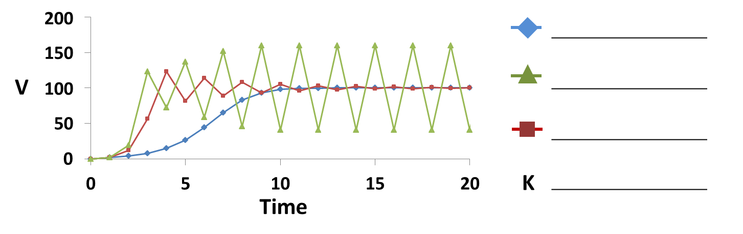
- Draw a figure below that illustrates how the predator feeding rate changes with prey density for both a type I and a type II functional response (i.e., two relationships on the same figure; be sure to label the relationships). Which functional response (type I or type II) represents predator satiation?

- If we relax the assumption that predators have scramble density dependence, and instead assume predators have contest density dependence, would we expect more or less regulation of prey?

- Imagine a bluegill population introduced to a lake with no predatory fish (but abundant prey for the bluegill and high anthropogenic phosphorus loading to the lake that allows for high primary productivity and subsequent high turnover rates of bluegill prey). Would a natural regulation strategy work for the bluegill population if the goal is to create a “trophy” bluegill fishery? Why or why not? If you are not familiar with bluegill fisheries, skip this question!

- Imagine a wild turkey population re-introduced to an area with sufficient prey and multiple predators of turkey eggs (e.g., raccoons, foxes, snakes, and owls). If the management goal is to provide some hunting opportunities for wild turkey (while limiting vehicle-turkey collisions – turkeys do more damage than you might think!), would a natural regulation strategy be appropriate? Why or why not?

