FW364 Spring 2012
Predation Practice Problems – KEY

Refer to the figure below for questions 1 through 3:

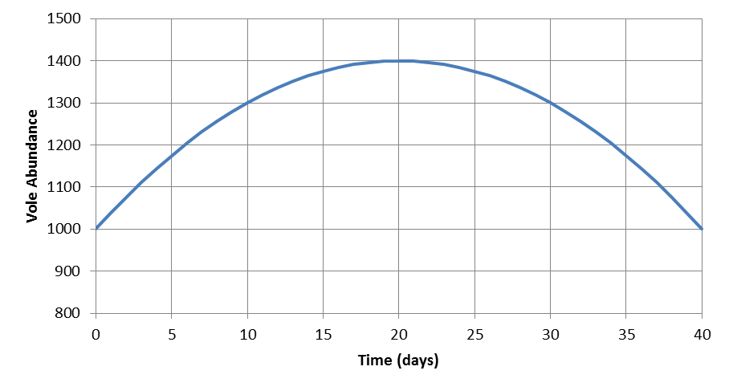
B
A

- What is the average population growth rate for the 40 day period?

To calculate the average population growth rate, draw a line that connects the starting population size (at day 0) to the ending population size (at day 40); this line is represented by the dot-dash line on the figure above. Calculate the slope of the line to determine the average population growth:

Slope = rise / run = (1000 – 1000 voles) / (40 – 0 days) = 0 voles / day

Average population growth rate = 0 voles / day No net growth!

- What is the growth rate at points A and B (using tangent method)?

To calculate the growth rate, draw a line tangent to the curve at each point (see dashed lines on figure) and calculate the slope of those lines.

Point A: Slope = (1400 – 1200 voles) / (15 – 5 days) = 20 voles / day
Point B: Slope = (1320 – 1420 voles) / (30 – 20 days) = -10 voles / day

- For what days was the (instantaneous) growth rate:

a. negative Days:___20-40____

b. positive Days:___0-20_____

c. zero Days:____20______

- Provide the units for each of the quantities below (note: some of the quantities may be repeated):

- V Units:__prey_______________

- P Units:__predators__________

- a Units:__1/(predator*time)____

- aV Units:__prey/(predator*time)_

- aP Units:__1/time______________

- aVP Units:__prey/time___________

- c Units:__predator/prey_______

- acV Units:__1/time______________

- predator feeding rate Units:__prey/(predator*time) (units for aV)_

- predator attack rate Units:__1/(predator*time) (units for a)_____

- Below are two of the equations we used to develop our coupled predator-prey equations. Circle the parameter in each model that we used to link the two equations (i.e., circle the parameter that we modified to create explicit linkages between the predator and prey equations).

$${dV}/{dt}=b_{v}V- d_{v}V$$

$${dP}/{dt}=b_{p}P-d_{p}P$$

The prey equation (dV/dt) is coupled to the predator equation through the prey death rate. Specifically, we “split-apart” d_{v} above into non-predatory deaths (which we continued to call d_{v}) and predatory deaths (which we defined as aP).

The predator equation (dP/dt) is coupled to the prey equation through the predator birth rate. Specifically, we replaced b_{p} above with acV.

- What are the predator and prey instantaneous growth rates (i.e., what are dV/dt and dP/dt) when there are 1000 prey, 10 predators, predators convert 15% of what they consume into predator production, and each predator consumes 2 prey per day? Assume the “background” death rate for both the predator and prey is 10% per day and that the prey have a birth rate of 0.60 per day. Use the equations below to calculate your answers.

$${dV}/{dt}=b_{v}V- d_{v}V-aVP$$

$${dP}/{dt}=acVP-d_{p}P$$
Givens:

V = 1000 prey
P = 10 predators
c = 0.15 predators/prey (i.e., c is conversion efficiency of prey into predators)
aV = 2 prey/(predator*day) (i.e., aV is how many prey each predator consumes per day)
d_{v} = 0.10 /day (i.e., d_{v} is the background death rate for prey)
d_{p} = 0.10 /day (i.e., d_{p} is the background death rate for predators)
b_{v} = 0.60 /day (i.e., b_{v} is prey birth rate)

Plugging the givens into the equations yields:
$${dV}/{dt}=0.60 \frac{1}{day}*1000 prey-0.10\frac{1}{day}*1000 prey -2 \frac{prey}{predator*day}*10 predators$$

$${dV}/{dt}=480 prey$$

$${dP}/{dt}=2 \frac{prey}{predator*day}*0.15 \frac{predators}{prey}*10 predators-0.10 \frac{1}{day}*10 predators$$

$${dP}/{dt}=2 predators$$

- If a single meerkat can consume 0.5% of a scorpion population in a day, and there are 600 scorpions and 15 meerkats: a) what is the feeding rate of the meerkats, and b) how many scorpions would the entire meerkat population consume in a day?

Givens
V = 600 scorpions
P = 15 meerkats
a = 0.005 /(meerkat*day)

- The feeding rate is aV
aV = 0.005 /(meerkat*day) * 600 scorpions = 3 scorpions / (meerkat *day)

- The total number of scorpions consumed by the entire meerkat population in a day is aVP
aVP = 0.005 /(meerkat*day) * 600 scorpions * 15 meerkats = 45 scorpions/day
- Solve the prey growth rate equation from question 6 for the predator abundance at equilibrium. Why do we use the prey growth rate equation to determine predator abundance at equilibrium?

Starting equation: ${dV}/{dt}=b_{v}V- d_{v}V-aVP$

At equilibrium, dV/dt = 0, so $0=b_{v}V^{*}- d_{v}V^{*}-aV^{*}P^{*}$
Don’t forget to add the * after V and P!

Complete the algebra below to isolate P*
$aV^{*}P^{*}=b_{v}V^{*}- d_{v}V^{*}$ $\frac{aV^{*}P^{*}}{aV^{*}}=\frac{b_{v}V^{*}- d_{v}V^{*}}{aV^{*}}$ $P^{*}=\frac{b_{v}- d_{v}}{a}$

From the predator perspective, we determine the predator abundance at equilibrium (P*) using the prey equation because prey growth determines predator abundance at equilibrium. From the prey perspective, we determine the predator abundance at equilibrium (P*) using the prey equation because P* is the number of predators needed to hold the prey at the prey equilibrium.

- Solve the predator growth rate equation from question 6 for the prey abundance at equilibrium. Why do we use the predator growth rate equation to determine prey abundance at equilibrium?

Starting equation: ${dP}/{dt}=acVP- d_{p}P$

At equilibrium, dP/dt = 0, so $0=acV^{*}P^{*}- d_{p}P^{*}$
Don’t forget to add the * after V and P!

Complete the algebra below to isolate V*
$acV^{*}P^{*}=d_{p}P^{*}$ $\frac{a{cV}^{*}P^{*}}{a{cP}^{*}}=\frac{ d_{p}P^{*}}{acP^{*}}$ $V^{*}=\frac{d_{p}}{ac}$

From the prey perspective, we determine the prey abundance at equilibrium (V*) using the predator equation because predator growth determines prey abundance at equilibrium. From the predator perspective, we determine the prey abundance at equilibrium (V*) using the predator equation because V* is the number of prey needed to hold the predators at the predator equilibrium.

- According to the equations in question 6, what happens to the prey in the absence of predation?

Prey grow exponentially in the absence of predation. Specifically, when there are no predators (P = 0), the aVP term equals 0, leaving b_{v}V – d_{v}V, which describes exponential prey growth (at a rate of b_{v} – d_{v} = r_{v})
- According to the equations in question 6, what happens to the predators in the absence of prey?

Predators decline (to extinction) exponentially in the absence of prey.
Specifically, when there are no prey (V = 0), the acVP term becomes 0, leaving only the d_{p}P term which describes exponential decline of the predator at a rate d_{p}.

- What is the assumption involved when we multiply V and P (i.e., VP in the equations in question 6)?

The assumption is that the predators and prey encounter each other randomly (i.e., the environment is well mixed).

- What type of functional response do the predators have in the equation in question 6?

The predator has a Type I functional response, i.e., a non-saturating functional response (the predator feeding rate, aV, increases linearly with prey density).

- What type of density dependence do the prey have in the equation in question 6?

Trick question: no density dependence of the prey!

- What type of density dependence do the predators have in the equation in question 6?

Predators exhibit scramble density dependence; predator growth is limited by prey abundance by the acV term.

- The equations in question 6 may describe (circle all that apply):

  - the rate of change in abundance of predator and prey populations
  - abundance of predators and prey at specific times
  - coupled herbivore-plant interactions
  - coupled parasite-host interactions

- To include prey scramble density dependence in the prey equation in question 6, what parameter do we alter? What expression do we substitute in place of the parameter?

Given the prey equation: ${dV}/{dt}=b_{v}V- d_{v}V-aVP$, we incorporate scramble density dependence through the prey birth rate, b_{v}. We substitute the following expression:
b_{v} = b_{max} (1-V/K).

- If you have not completed question 17 already, do that question before this question!
To include density dependence in the prey population, we use the expression b_{max} (1-V/K) in place of the prey birth rate, b_{v}, in the prey equation. At what prey population size (low, intermediate, or high) does the prey birth rate approach b_{max}? What happens to the prey birth rate when the prey population approaches carrying capacity?

The prey birth rate approaches b_{max} at low population sizes (i.e., under low competition). The prey birth rate declines to zero when the prey population approaches carrying capacity.

- Draw a figure below that illustrates how the prey birth rate changes with prey density under no density dependence and under scramble density dependence (i.e., two lines on the same figure; be sure to label your lines). For the relationship under scramble density dependence, mark where b_{max} and K occur on the figure.

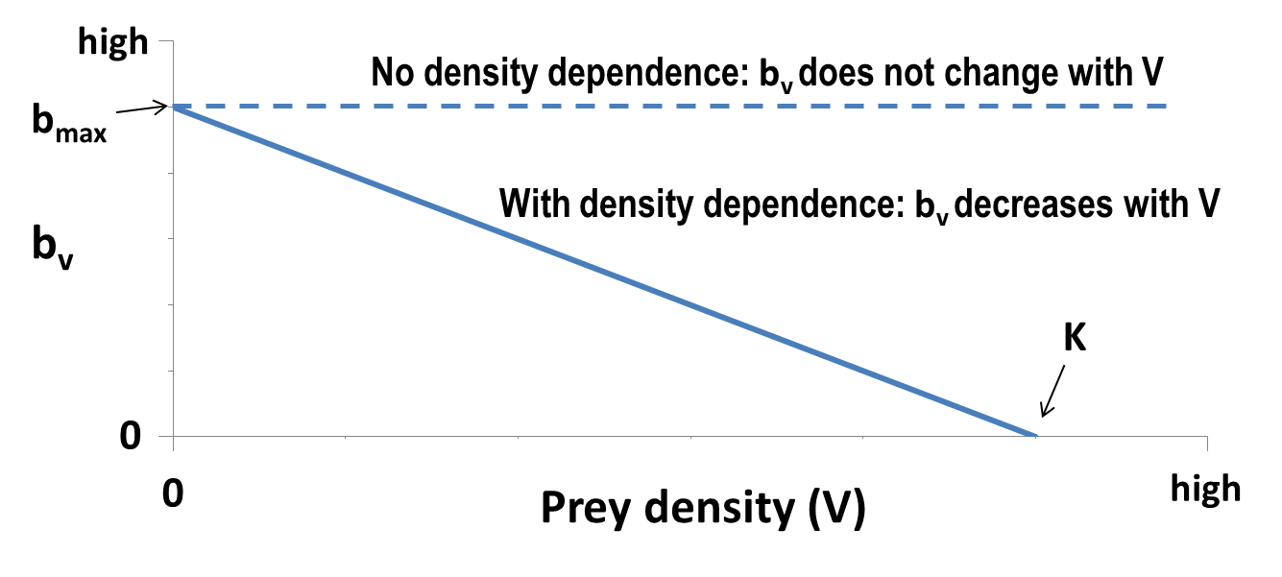

- When prey scramble density dependence is added to the prey equation, what changes occur to the predator equation?

  - the predator birth rate, b_{p}, changes to b_{max} (1-P/K)
  - the predator death rate, d_{p}, changes to d_{max} (1-P/K)
  - the predator attack rate, a, becomes a function of maximum prey birth rate, b_{max}
  - no changes occur to the predator equation

- In the figure below, label the trajectories as exhibiting either a smooth approach to carrying capacity, damped oscillations around carrying capacity, or a stable limit cycle. What is the carrying capacity in this figure?

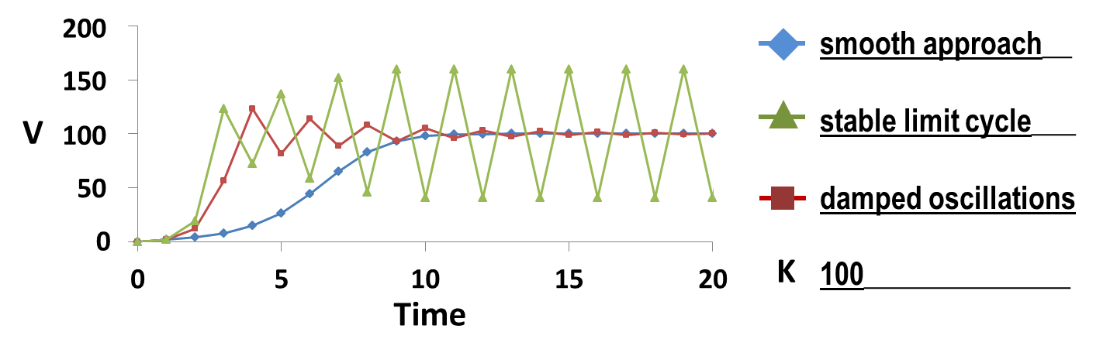
- Draw a figure below that illustrates how the predator feeding rate changes with prey density for both a type I and a type II functional response (i.e., two relationships on the same figure; be sure to label the relationships). Which functional response (type I or type II) represents predator satiation?
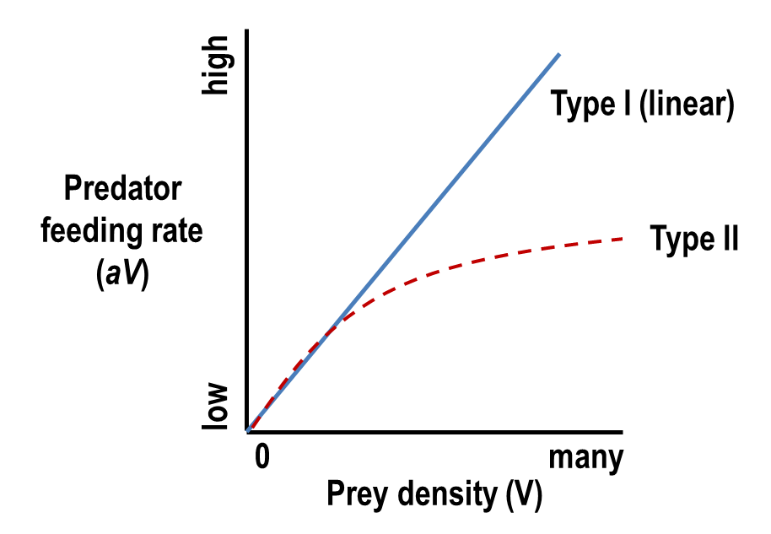
Type II functional response represents predator satiation

- If we relax the assumption that predators have scramble density dependence, and instead assume predators have contest density dependence, would we expect more or less regulation of prey?

We would expect less regulation of prey with contest density dependence of predators since predators may reach an upper limit (based on, e.g., number of territories) that is below what the prey supply could support.

- Imagine a bluegill population introduced to a lake with no predatory fish (but abundant prey for the bluegill and high anthropogenic phosphorus loading to the lake that allows for high primary productivity and subsequent high turnover rates of bluegill prey). Would a natural regulation strategy work for the bluegill population if the goal is to create a “trophy” bluegill fishery? Why or why not? If you are not familiar with bluegill fisheries, skip this question!

No, a natural regulation strategy would not work for the bluegill population. Given abundant prey and high prey turnover, the bluegill will likely have a high carrying capacity. Bluegill are well known to exhibit stunted growth at high densities (i.e., size-at-age is smaller for bluegill at high densities), so the fishery will not offer many “trophy” bluegill. If a predator fish (e.g., northern pike) was present in the lake, natural regulation might work.

- Imagine a wild turkey population re-introduced to an area with sufficient prey and multiple predators of turkey eggs (e.g., raccoons, foxes, snakes, and owls). If the management goal is to provide some hunting opportunities for wild turkey (while limiting vehicle-turkey collisions – turkeys do more damage than you might think!), would a natural regulation strategy be appropriate? Why or why not?

Yes, a natural regulation strategy would likely work for the turkey population. The numerous egg predators would likely keep the turkey population below the turkey carrying capacity that would occur in the absence of predation. With a lower total population of turkeys, turkey-vehicle collisions would likely be reduced. Thus, both management goals would be met (providing some hunting opportunities while limiting collisions).

